

Prajna Jagannath

Shagufta Hassan

Durafshan Jawad

Madesh Ramesh

Lama Alznaidi

**George Mason University**

10/30/2022

**DAEN 690**

**Project Report**

**Data Tagging**

**via Contents and Standards**

**Fall**

**2022**

Table of Contents

Abstract 7

1 Introduction 8

1.1 Background 8

1.2 Problem Space 11

1.3 Research 11

1.4 Solution Space 13

1.5 Project Objectives 14

1.5.1 Business Objectives 14

1.5.2 Technical Objectives 14

1.5.3 Learning Objectives 14

1.6 Primary User Stories: 15

1.7 Product Vision – Advanced Use Cases 15

Scenario #1 15

Scenario #2 15

1.8 Definition of Terms: 16

2 Data Acquisition 16

2.1 Data Collection and Field Descriptions 17

2.2 Data Context 22

2.3 Data Conditioning 23

2.4 Data Quality Assessment: 25

2.5 Other Data Sources 25

3 Analytics and Algorithms 27

3.1 System Environment 27

3.2 Solution Schematics 27

3.3 Project Analytics Steps 28

3.3.1 Step 1: Extract clean text, title, and published date 28

3.3.2 Step 2: Extract entity keywords – Person, Location, Organization 29

3.3.3 Step 3: Identify and tag topics from extracted clean text using LDA 29

4 Visualization 37

4.1 Visualizations for Exploratory Data Analysis 37

4.1.1 CNN Dataset 37

4.1.2 BBC News Dataset 37

4.1.3 Aljazeera News Dataset 38

4.1.4 Japan Times News Dataset 38

4.1.5 CNBC News Dataset 39

4.2 Visualization for preprocessing text: 40

4.2.1 Unigrams 40

4.2.2 Bigrams 40

4.2.3 Trigrams 41

4.3 Visualizations for Topic Modeling 42

4.3.1 Topic Modeling Results for CNN 42

4.3.2 Topic Modeling Results for BBC 44

4.3.3 Topic Modeling Results for Al-Jazeera: 46

4.3.4 Topic Modeling Results for Japan Times 49

4.3.5 Topic Modeling Results for CNBC 50

5 Findings 52

5.1 Preprocessor Mechanism 52

5.2 System to identify Best Descriptor Tag 52

5.3 Model Tuner 53

5.4 Baseline Standard for Tagging - DCAT 54

5.5 Use Case Scenario 55

5.6 Lessons Learned 55

6 Summary 56

7 Future Work 56

8 Appendix A: Code References 58

8.1 GitHub 58

8.2 Data Location 58

8.3 Code Instructions 58

8.4 Credits 58

9 Appendix B: Risk Section 59

a. Sprint 1 Risks 59

b. Sprint 2 Risks 59

c. Sprint 3 Risks 60

d. Sprint 4 Risks 61

e. Sprint 5 Risks 61

8 Appendix C: Agile Development 62

a. Scrum Methodology 62

b. Sprint 1 Analysis 63

c. Sprint 2 Analysis 63

d. Sprint 3 Analysis 63

e. Sprint 4 Analysis 63

f. Sprint 5 Analysis 64

9 Appendix D: Additional Visualizations and Graphics 64

a. Text Preprocessing for Aljazeera (Unigrams, Bigrams and Trigrams) 64

b. Text Preprocessing for Aljazeera (Unigrams, Bigrams and Trigrams) 65

c. Text Preprocessing for Japan Times (Unigrams, Bigrams and Trigrams) 66

10 References 69

# 

|  |
| --- |
| Table of Figures  Figure 1: Challenge Without Data Catalog & Solution with Data Catalog [12] 9  Figure 2: Data Catalog Users Drive Enhanced Business Execution [13] 9  Figure 3: CNBC news dataset field description 17  Figure 4: Sample Al Jazeera news dataset 18  Figure 5: Sample BBC UK news dataset fields description 19  Figure 6: Japan Times news dataset fields description 20  Figure 7: Sample CNN news dataset 21  Figure 8: Checking null/missing values for one of the datasets 23  Figure 9: Identified duplicate rows for one of the datasets 24  Figure 10: Identified invalid URLs for one of the datasets 24  Figure 11: Saving dataset to CSV file to maintain consistency of files formats 25  Figure 12: DCAT Scope 26  Figure 13: Solution Schematics 27  Figure 14: Extracting title, published date and clean text from URL 29  Figure 15: Extracting named entity tags 29  Figure 16: Text before and after preprocessing 30  Figure 17: Master Dictionary created using 3 largest and most diverse dataset 31  Figure 18: Initial LDA model using Aljazeera corpus 32  Figure 19: Identifying dominant topics and its keywords using the model (Aljazeera) 33  Figure 20: Coherence and perplexity of the gensim model 34  Figure 21: : Intertopic Distance Map showing topic clusters with corresponding keywords 34  Figure 22: Finding optimal number of topics to classify the Aljazeera dataset 35  Figure 23: : Creation of topic clusters by rerunning the model with new-found optimal number of topics 36  Figure 24: Identify the best descriptor for each topic collection 36  Figure 25: Adding identified topics to the Aljazeera Dataset for classifying them 36  Figure 26: Group collections as individual dataframes 37  Figure 27: Roll-up Collections via Keyword Frequency and Tag Them 37  Figure 28: Final Tagged Collections in a Catalog 38  Figure 29: Word Cloud from CNN news dataset 39  Figure 30: Word Cloud from BBC UK dataset 39  Figure 31: Word Cloud from Aljazeera English news dataset 40  Figure 32: Word Cloud from Japan Times news dataset 40  Figure 33: Word Cloud from CNBC news dataset 41  Figure 34:Word Cloud from CNBC news dataset 42  Figure 35: Top 20 unigrams after removing stop words 42  Figure 36: Top 20 bigrams before removing stop words 42  Figure 37: Top 20 bigrams after removing stop words 43  Figure 38: Top 20 trigrams before removing stop words 43  Figure 39: Top 20 trigrams after removing stop words 43  Figure 40: Intertopic Distance Map for CNN 44  Figure 41: Word Count and importance of Topic Keywords 45  Figure 42: Labeling of Topics based on Keywords 46  Figure 43: Intertopic Distance Map for BBC 46  Figure 44: Word Count and importance of Topic Keywords 47  Figure 45: Labeling of Topics based on Keywords 48  Figure 46: Intertopic Distance Map for Aljazeera 48  Figure 47: Word Count and importance of Topic Keywords 49  Figure 48: Labeling of Topics based on Keywords 50  Figure 49: Intertopic Distance Map for Japan Times 50  Figure 50: Word Count and importance of Topic Keywords 51  Figure 51: Labeling of Topics based on Keyword 52  Figure 52: Intertopic Distance Map for CNBC 52  Figure 53: Word Count and importance of Topic Keywords 53  Figure 54: Labeling of Topics based on Keyword 54  Figure 55: Finding optimal number of topics to classify the CNN dataset 56  Figure 56: Tagged Package of CNN with DCAT field names 56  Figure 57: Use Case Scenario for Catalog Search Engine 57 |

|  |
| --- |
| Table of Tables  Table 1: Definition of Terms 15  Table 2: Dataset Inventory Table 16  Table 3: CNBC news dataset field description 17  Table 4: Sample Al Jazeera news dataset fields description 18  Table 5: BBC UK news dataset fields description 19  Table 6: Japan Times news dataset fields description 20  Table 7: Sample CNN news dataset field description 21  Table 8: Performance Comparison before and after Tuning Topic Model 55 |

# Abstract

Data Tagging is the practice of assigning descriptor terms that describe digital content such as articles, images, or videos. These metadata tags enable discovery via data catalogs. Yet, with ever-growing digital content, it is hard to keep the practice of tagging manually and arbitrarily in addition to maintaining a gold standard. to enable interoperability during data exchange between organizations.

Data Bees Team’s Project aims to leverage tags drawn from texts that allow the organization to automate the process of organizing their inventory of data assets with standard and structured tags. There is a great deal of research already going on data tagging and to achieve the tagging with accuracy is being the challenging part of this research area. Another hinderance with so many solutions popping up is picking a fixed standard that everyone can agree on and adhere to.

Our project solution entails admin tagging, domain tagging and topic mapping. Admin tags describe data such as published date, person, organization, and location. Domain tags describe what topics best describe the content of the data. Topic Mapping clusters text data based on their similarity in order to map them to a certain topic. We leveraged W3C’s Data Catalog Vocabulary (DCAT, <https://www.w3.org/TR/vocab-dcat-3/>) as the baseline standard for tagging and building upon in to achieve a tagging solution with a standard that enables interoperability.

In order for the team to accomplish this, we utilized six different news datasets collected from data.world website. We used web scraping techniques to extract admin tags, applied Latent Dirichlet Allocation (LDA) algorithm by creating an ML/AI model to extract domain keywords/tags, and mapped topics to text using LDA output. We also used different visualizations, to provide results’ insights that show that the tags help avoid problems caused by inaccuracies and help find the inaccuracies themselves.

# Introduction

## Background

Data has been around us for decades, however, today we are generating ever-increasing volumes of various varieties of data. Every day enormous (1.145 trillion MB per day [1]) volumes of data are generated that are mostly unstructured or semi-structured [2]which makes it harder to analyze and drive insights from it. According to a Webopedia report, 80 to 90 percent [3] of the world’s data is unstructured which is generated from various sources like server logs, internet streaming, social media content, emails, etc. Because of the use cases of big data, its application can be found in various sectors like manufacturing, healthcare, education, media and entertainment, banking, securities, etc.

Over centuries, companies have been trying to use data analysis techniques to generate sense out of raw data to support their decision-making process. Data is an asset in a case if business users can transform it into meaningful customer insights. By examining the vast amounts of data, firms can identify patterns and decide if the proposed technique is going to solve the given problem or not. In any data organization strategy, understanding the data’s structure is the key to unlocking its value [4].

For this, data classification is broadly defined as the process of organizing and tagging data by categories, content, and standards. It can be considered as a folder, where it keeps all the important documents in the most arranged, logical, and orderly fashion. It allows everyone to easily find what they are looking for by making the search query the most efficient. Another term that comes into play in identifying and describing data is metadata which contains information about data (also known as the data about data). To make the benefit of data classification, metadata is needed to support the compatibility and usability of related data.

This will lead us to the process of tagging which is the activity of creating an identification or description by affixing a suitable tag on the data to be identified or described based on specific characteristics. Data tagging is used for classification, identification, arrangement, and organization of content of data. The tag can be considered as a metadata for the content on the internet by providing additional information about the content. It helps to locate content in the unimaginably large universe of data. So, for example in the case of publications, when a piece of content is added on the web, a content tag is supposed to connect the publication to other pieces of content that are similarly tagged. This is the basic working of search engines where they use tags to identify content and produce accurate hierarchical or non-hierarchical keywords [5]and can be used for Internet bookmarks, digital images, videos, files and so on.

Data tagging can be in the format of key-value pairs [6] and can be done manually or automatically to help answer ad-hoc queries easily and efficiently. Manual tagging is usually done by a small group of people in a company who are supposed to stay aligned with the content strategy of the organization. This is an expensive approach of tagging as it leverages the time of qualified resources (mostly employees) who could be spending their time doing other things for the company. Besides that, as the company starts to ramp up the volume of content, it becomes an arduous task to tag big data manually as capacity becomes a challenge. To come over this problem, companies are trying to produce some automated tagging solutions. Technologies are investing their time and money to build models that rely on Natural Language Processing (NLP) and semantic extraction engines to add contextual metadata to data catalog based on the tags. Engines and tools might not have the fine sensibilities of the human mind to always make the right choices.

The data used for tagging can be in various places like in a typical relational database, cloud, data lake or in a file. From that idea of a data catalog came. To explain the data catalog, consider an example of a library catalog [7] which helps you find out whether a particular book is available in a library or not. Along with its availability, it also provides information like author, edition, published date by going through the overview. In short, the catalog gives various details of the book based on its content and provides the exact location where it can be accessed in the library.

A data catalog will look at all distinct types of data you have in an organization and put it together and organize it into one place. Data catalogs are used to index where everything is stored. It uses metadata, to collect, tag, and store datasets. You can think of a data catalog as a retailer’s catalog, but instead of giving information about products it gives you information about data elements within an organization [8]. It is used to better discover, understand, and manage all the data assets [9]. Data catalog provides you with a simple-to-use search interface for data discovery to build a custom application. With data catalogs, you maintain tags that let you organize your inventory of data assets with structured tags [10]. These tags help to capture any complex business metadata like owner, creation date and creator of data etc.

If an organization does not have a data catalog, there are chances that each group is creating their own sets of documentation and metadata to describe the same type of data which can result in duplicated effort and incomplete information. Documenting these data entries on a huge scale is difficult, especially when this documentation is done by distinct groups in an organization as they have varying needs which raises the problem of not having a specific standard throughout the organization. Most probably each group creates their own set of metadata according to their standards to describe the same data, resulting in duplicated effort of sorting and data with no standard that can be used within distinct groups of an organization [11].A data catalog in short organizes the technical details around the data assets, or metadata, into defined, meaningful, and searchable business assets to enable consistent understanding among all data users and consumers. Figure 1 explains the potential challenges without Data Catalog.

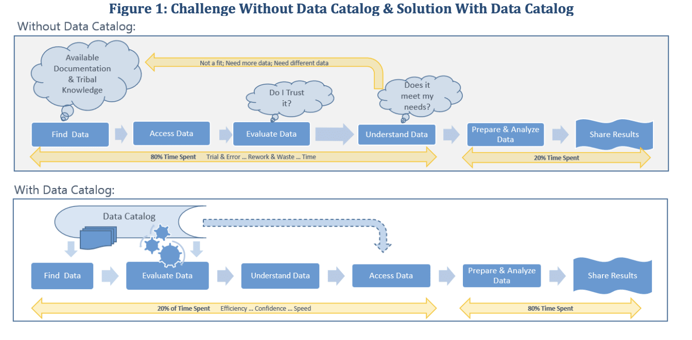

Figure 1: Challenge Without Data Catalog & Solution with Data Catalog [12]

Data catalogs have been in the market for a long time, and provide a place for people to find where data is and how it is used. Before catalogs, organizations must keep track of the source of data and its flow within the organization using metadata management tools which is a tedious task. Data cataloging helps organizations in revenue growth, increases customer satisfaction, and generates profit. The visualization below (Figure 2) is taken from ‘Aberdeen Strategy & Research’ [13]which shows data cataloging helps in about a 10% growth increase of revenue of their organization.

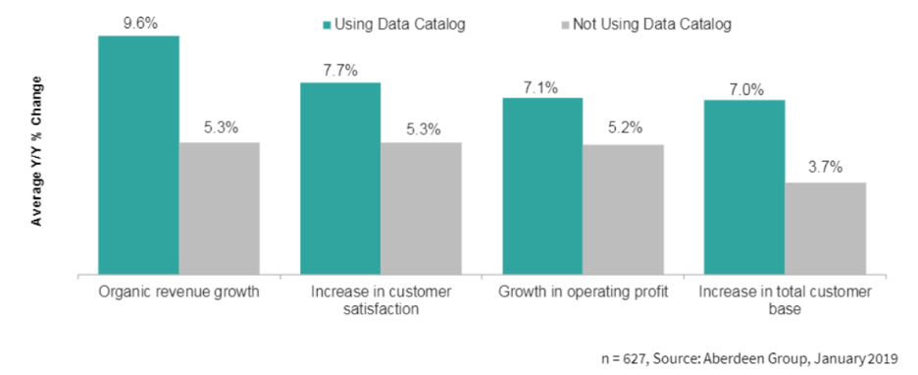

Figure 2: Data Catalog Users Drive Enhanced Business Execution [13]

## Problem Space

To identify and harvest value out of data, data engineers, analysts, consumers, and other relevant stakeholders need to know what data exists in their repository, the means to use it, and its quality and trustworthiness. This becomes very necessary especially when it comes to unstructured data where tagging is the one that brings structure to it. These days tagging is done by manual effort or partially with the assistance of tools that can scan data for parameters of interest. Effective tagging will need to be accurate, consistent and with so much sensitivity of value attributed to it, it is a time-consuming process when done manually. To automate this, a solution with applications of machine learning, artificial intelligence etc. will be developed which will help tagging to be done anytime while reducing errors.

Organizations around the world will have plenty of legacies and live data about events happening all over the world coming in at enormous speeds. This ingestion of Big Data if not handled and tagged systematically could be a huge mess of text dump. Doing this manually is once again not efficient and so these call for a solution to automate the process.

Without the solution, tagging will have to be done manually, thus; data discovery and data standardization will be an exceedingly arduous process. The solution will be to create an ML/AI model with ‘Topic Modeling’ that can identify, categorize, and tag news data based on content, while also focusing on standardization of the generated tags. Topic Modeling is the ability of the model to categorize articles based on content. In short, the project’s problem space will revolve around automating metadata tagging, maintaining domain specific standards (e.g., news and media), allowing users to manage an organized data inventory of high quality with news/media data as the domain of focus.

## Research

The project team used a database with thousands of rows that contained URLs pointing to current articles on the web to perform research on recent publications. The goal of our project is to extract the keywords from each of these articles and present them to users when they request a specific search. It would be exceedingly slow, expensive, and full of errors for a regular person to be able to search through a repository's enormous amount of data using only text.

Although manual tagging is effective, it requires a lot of labor and is difficult to scale and standardize. A machine learning-based automatic tagging system might be able to satisfy these requirements. The use of keyword tags in research papers and publications by software has long been used to address some of these issues. The core concepts of text data are made visible and searchable with keyword labeling. The prominence of this concept improves search, which improves data use, administration, and access. To make this possible, we must divide the process into two steps: first, we must extract the keywords from the content that best describe it, and second, we must efficiently handle the keyword search request.

Text Mining: How to Extract Valuable Insights from Text Data by Amal Joby[14] was one of the few academic articles that we discovered that would benefit us in tagging and classification of data. This article clarifies the use of a technique called text mining to extract reliable, key information from such massive amounts of text data. Text is processed using various approaches, such as natural language processing, via text mining (NLP).

Natural language processing uses a variety of machine learning approaches to extract the meaning from each sentence and convert it into a form that computers can comprehend. To understand human language, we need a way that enables computers to understand the context of sentences in a way that is like how people do. Additionally, syntactic analysis can be used to determine how closely a natural language adheres to grammatical norms. A field of linguistics investigates the rules for organizing words in sentences, so they make grammatical sense. These two methods are the main ones for doing tasks involving natural language processing. These are a few methods we tried in our project.

Fabio Chiusano describes how to assess a large volume of text data, such as a stream of articles from internet blogs, through the process of assigning topics to the content of various forms in his work How to train a Topic Tagging model to assign high-quality themes to articles[15]. According to the author, predictive topic tagging is a method for predicting high-quality articles' themes and makes it simple to train a model with respectable quality.

Predictive topic tagging[15] makes use of a predetermined set of subjects and employs a variety of texts as training samples for a classification model. The training set can be scraped from the internet because every article that has been published and includes tags can be used as an example. The author used Pandas and NumPy for data processing, NLTK to normalize text, and Sklearn for the machine learning model to train the Topic Tagging model using scraped HTML (Hypertext Markup Language) from several articles. I have also added recommendations to enhance the job. Split the dataset into train and test segments and evaluate the model using appropriate criteria. Adjust each binary classifier's classification threshold to perfection. Obtain training information from many websites. Taxonomies improve the compilation of training data.

However, the author also claims that the suggestions made in the section on potential enhancements significantly raised the quality of the final model. The automatic examination of several texts yields potential use cases, such as competitor or social media analysis.

We have utilized "Topic Modeling" to extract high-quality, significant, and clear subjects from a group of articles. This model, which contains information about the text, is probabilistic. For the purposes of organizing huge blocks of textual data, document clustering, information retrieval from unstructured text, and feature selection, topic models are helpful. Finding excellent topics depends on the topic modeling algorithm chosen, the number of topics given in the algorithm, and the quality of text processing.

Many techniques can be used to extract these keywords; however, we are applying the Latent Dirichlet Allocation (LDA) from the Gensim package in conjunction with the Mallet's implementation (via Gensim). Mallet has a successful LDA implementation. It is reputed to operate more quickly and provide greater topic separation.

In LDA's topic modeling strategy, each document is viewed as a collection of topics, and each topic is viewed as a collection of keywords. Here, topics are a grouping of well-known words or phrases that have the highest likelihood of being related to the topic, making it easier to determine what the topics are about. The algorithm just rearranges the distribution of subjects within documents and the distribution of keywords within topics once we give it several topics to generate a suitable composition of topic-keyword distribution.

Greg Rafferty's topic model using Latent Dirichlet Allocation [16], which is a generative probabilistic model of (in NLP jargon) a corpus of documents made up of words and/or phrases, explains how he employed Latent Dirichlet Allocation in his research. The model consists of two tables: one shows the likelihood of choosing a certain word from the corpus when sampling from a specific subject, and the other shows the likelihood of choosing a specific topic when sampling from a specific text.

The key factors in obtaining good topic segregation [17] is the quality of text processing, the variety of topics discussed in the text, and the choice of topic modeling algorithm, as well as the number of topics fed to the algorithms and their tuning parameters. The parameters included are the higher alpha. It is anticipated that documents are composed of more subjects, resulting in a more precise topic distribution for each document. The alpha parameter is a Dirichlet prior concentration parameter that measures document-topic density. Secondly, the beta parameter, which previously represented topic-word density, is the same. When beta is large, it is presumed that subjects make up most of the words, which leads to a more focused word distribution per topic.

Text preparation is incredibly simple with the preprocess string technique. Punctuation, HTML tags, numerous white spaces, non-alphabetic letters, stop words, and even text stemming are automatically removed by default.

## Solution Space

The Data Bees team’s solution provides value to users by automating data tagging activity with accurate tags, resolving the difficulties in arbitrary manual tagging, and maintaining standards. The users get value when they save time and effort spent on manual tagging and when they prevent the inherent human errors that come with it. Additionally, the inconsistent tagging standards are reformed by setting a gold standard for tagging using DCAT vocabulary that not only helps better organization and discovery of data but also all enables interoperability between organizations during data exchange. The value addition through our solution will be to ensure that the right news is put in front of the right people at the right time and this content tagging product will help organizations manage inventory and deliver content accurately and in a timely manner. This is achieved by the automation of tagging and implementing it at the point of data ingestion to tag real-time data as it comes.

## Project Objectives

## Business Objectives

The project objective is to automate the process of tagging data for preparing a data catalog. The generated metadata tags are ensured to be of domain-specific standards and ones that can overcome the problem of semantic ambiguity and sufficient (not too many and not too few). It will be one of the ways to enable baseline discovery via tags. Tagging not only allows users to engage an individual, business, or any entity with a social profile when they mention them in a post or comment but also helps to organize and distribute content. They make discovery of data more effective to enable more effective interrogation, investigation, and analysis of events more effective, and they help provide a better service to the readers and consumers of published news content. The solution resolves the problem of ambiguity and standards by automating data tagging activity with accurate tags.

## Technical Objectives

The aim is to achieve a machine learning solution that will tag the news data to enable news publishers to provide news feeds relating to specific subjects to be surfaced accurately and consistently. A ML/AI model with ‘Word Sense Disambiguation’ to identify, collect, and tag news data based on content, while also focusing on standardization of the generated tags is built. The Analytic/Algorithms to be used are NLP techniques like named-entity recognition, text summarization, topic modeling, and keyword extraction for extracting data tags from the text will be embedded in an AI engine/model to provide it with the ability to resolve semantic ambiguity. To standardize the vocabulary of the metadata tags, the vocabulary from DCAT is utilized to increase discoverability and make possible a unified search of datasets across catalogs from different sites.

For customer-facing organizations, it is particularly important to create personalized and relevant customer experiences and classified content needs to be intelligently delivered. Content classification goes a long way to solving the problems of organizations that possess a large content archive or are anticipating creating a large volume of content in the future. Improving the accuracy of metadata tags is something that end users must own.

## Learning Objectives

The learning of our project is to communicate data analysis results effectively and to recognize the limits of data analysis and to measure, manage, and manipulate complex data sets. Additionally, applying quantitative reasoning to select appropriate models for data analysis is a critical learning for all of us. Also, understanding how text analytics are used in Marketing, Management is one of the major learning objectives of our project.

Familiarity with Advanced syntax in Python, and an understanding of how to apply text analytics methods in Python using traditional and emerging methods for analyzing textual information will be a significant part of the knowledge gain.

## Primary User Stories:

Based on the user context and value proposition, we developed the following primary and secondary user story to guide our project:

1. As a data steward (of any television network/media), I want my tagging of active data that is being ingested to be automated to replace manual efforts saving time and making the findability of data more efficient with standardized tags.
2. As a developer, I want to use this solution to categorize my text data so that I can conduct further analysis and develop other NLP solutions.

## Product Vision – Advanced Use Cases

As a User (Any media organization with URL-based data inventory), I want to have my data discovery organized with standardized metadata tags for ease of sorting, searching, and granular analysis to extract value and increase revenue growth by gaining insight into viewers’ news consumption.

### Scenario #1

A news channel provides personalized news feeds based on the reader’s interest by utilizing the content tagging technique. The news tagging solution will help the news publisher to provide timely news updates to the end user based on the user’s interest area. Here we are making a product that could personalize news feed for the news subscriber where content tagging will be done. Some risks/caveats can be new terms the content tagging product is not trained with. For example, Covid19 related news in 2019 could be classified as its own domain and is a pandemic of unforeseen scale in recent times. Such uncommon event-related data may not be tagged as specifically and accurate as one would want. The mitigation plan is to lock the data, as constantly updating of the corpora again will require manual intervention.

### Scenario #2

Another far-sighted scenario would be data monitoring for a news network that wants to prevent any purposeful or accidental bias in its broadcasting routine. The analysis of metadata tags could tell a lot about the type and amount of content generated by the network. A news channel when analyzing their tags can figure that more negative tags are appearing in correlation with a particular political party while more positive tags appear with the other. This could mean a voluntary or involuntary bias, which in any case will help the network to investigate the validity of the bias and rectify it if there is one.

## Definition of Terms:

Table 1: Definition of Terms

|  |  |
| --- | --- |
| Terms | Definition |
| Structured Data | Highly specified data stored in predefined format which is easily searchable |
| Unstructured Data | It consists of several types of data stored in native formats e.g.: videos, text messages, images, emails etc. |
| Semi-structured Data | It does not have a fixed schema but offers some structure. |
| Correlation | Shows to what extent one variable is related to another. If the value of one variable increases, the value of another variable also increases, its positive correlation and if it does decrease, then it is a negative correlation. |
| Data Tagging | Data tagging is the classification, identification, arrangement, and organization of content of data. |
| Key-value pairs | Key is the unique data identifier, while value is the data being identified. |
| Data lake | A centralized repository to store and process enormous amounts of data in all three forms (structured, unstructured, semi-structured) disregarding their size. |
| Metadata | Data that gives information about the data i.e.: creation date, creator, file size etc. |

# Data Acquisition

The working set of datasets were pulled from the website, <https://data.world>, which is an enterprise data catalog as a collection of news datasets. The dataset collection is being done through web crawling by Crawl Feeds team and we have pulled them from data.world website. There are sample files for each of them and they in turn contain URL (Uniform Resource Locator) links opening to respective news articles and webpages. Complete datasets are also available for a price. For our project, we are using the five news collections itemized in Table 2, and an overview of each is provided in the sections below with a sample and the field descriptions.

Table 2: Dataset Inventory Table

| **Dataset Name** | **URL Link** |
| --- | --- |
| CNBC news dataset | <https://data.world/crawlfeeds/cnbc-news-dataset> |
| Al Jazeera English News dataset | <https://data.world/opensnippets/al-jazeera-news-dataset> |
| BBC UK News dataset | <https://data.world/opensnippets/al-jazeera-news-dataset> |
| The Japan Time dataset | <https://data.world/crawlfeeds/the-japan-times-news-dataset-may-31-2022> |
| CNN news dataset | <https://data.world/opensnippets/cnn-news-dataset> |

## Data Collection and Field Descriptions

CNBC news dataset

CNBC is a business and financial news dataset. Crawl Feeds is the owner of the dataset, and it is available in public domain. Sample dataset with 625 records available for free. A complete dataset with 430K + records is available for the price of $145. Figure 3 shows a sample of CNBC News dataset.

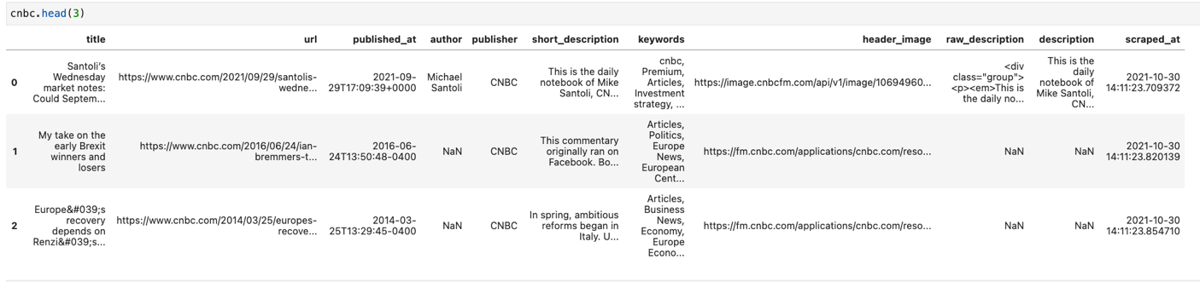

Figure 3: CNBC news dataset field description

The CNBC sample news dataset size is 5.16 MB (compressed) with 11 fields. The data’s period ranges between 2006 to 2021. Table 3 shows the CNBC news dataset field description.

Table 3:CNBC news dataset field description

| **Field** | **Type** | **Description** |
| --- | --- | --- |
| Title | Varchar2 | Title of news article |
| URL | URL | The web address or Universal Resource Locator for the webpage that contained the news article. This includes the protocol (http or https), host name, and subdomain. |
| published_at | Date | The publication date of the article in the format yyyy-MM-dd'T'HH:mm:ss'Z’ |
| author | Varchar2 | The author(s) of the news article |
| publisher | Varchar2 | The publisher of the news article |
| short_description | Varchar2 | A synopsis of what the article is about |
| keywords | Varchar2 | Tagged keyword |
| header_image | text/html | Link to access the header image |
| raw_description | Varchar2 | Description in HTML format |
| description | Varchar2 | Briefing about the article |
| scraped_at | Date | Date on which data has been scraped/Obtained |

Al Jazeera English News Dataset

Al Jazeera English News Is the international English-language television broadcasters. Crawl Feeds is the owner of the dataset, and it is available in public domain. The Sample dataset of 3,421 rows records. A larger dataset with more than 250K+ records last extracted on 2022 February’ 26 is available for a price of $145. Figure 4 shows a sample of Al Jazeera news dataset.

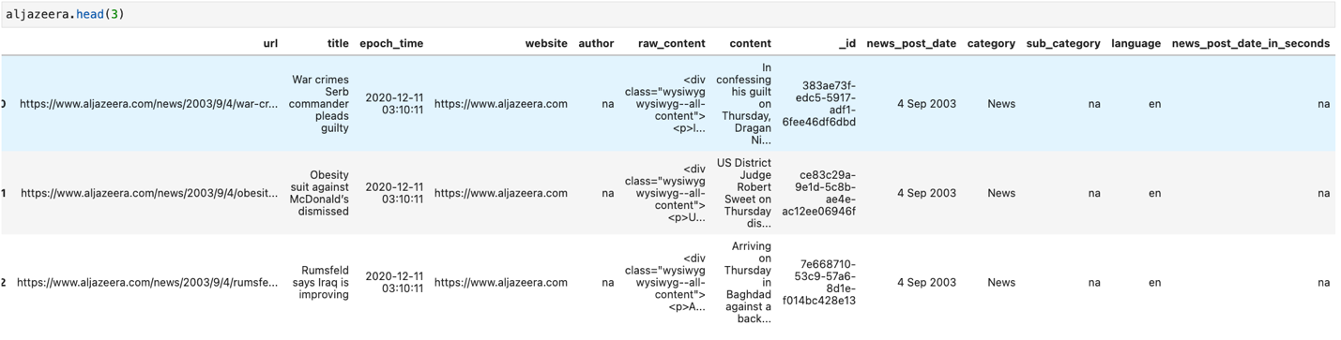

Figure 4: Sample Al Jazeera news dataset

The Al Jazeera English News sample dataset size is 25.99 MB (compressed) with 16 fields. It contains articles from September 2003 to December 2003. Table 4 shows the Aljazeera news dataset field description.

Table 4: Sample Al Jazeera news dataset fields description

|  |  |  |
| --- | --- | --- |
| **Field** | **Type** | **Description** |
| Title | Varchar2 | Title of news article |
| #epoch_time | Date | time considered to be the starting point |
| author | Varchar2 | The author(s) of the news article |
| URL | URL | The web address or Universal Resource Locator for the webpage that contained the news article. This includes the protocol (http or https), host name, and subdomain. |
| content | Varchar2 | Briefing about the article |
| raw_content | Varchar2 | Description in HTML format |
| id | Varchar2 | Unique id |
| news_post_date | Date | News Posting date |
| news_post_date_in_seconds | Date | News Posting date in seconds |
| header_image | Text/html | Link to access the header image |
| images | Text/html | Link to access the image |
| language | Varchar2 | Language used in the article |
| website | Varchar2 | Name of the website |
| category | Varchar2 | Dataset category |
| subcategory | Varchar2 | Dataset Subcategory |
| news_sub_header | Varchar2 | text appears below the main headline in an article |

BBC UK news dataset

British Broadcasting Corporation responsible for the gathering and broadcasting of news and current affairs in the UK and around the world. Crawl Feeds is the owner of the dataset, and it is available in public domain. The sample dataset has 15K+ records and is available for free. More than 1.17M records are available for a price of $225. Figure 5 shows. A sample BBC UK news dataset.

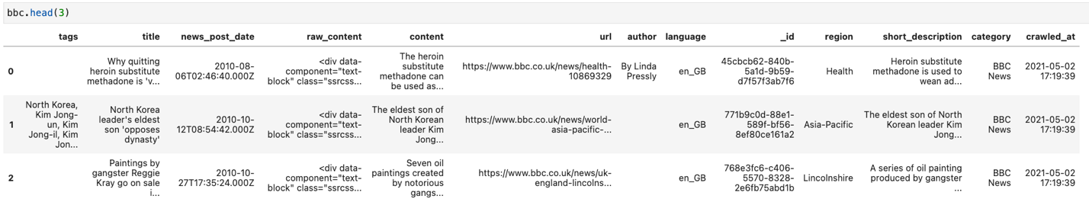

Figure 5: Sample BBC UK news dataset fields description

The BBC UK news sample dataset size is 93.99 MB (compressed) with 13 fields. It contains news data of articles published from April 2010 to March 2012. Table 5 shows the BBC UK news dataset field description.

Table 5: BBC UK news dataset fields description

|  |  |  |
| --- | --- | --- |
| **Field** | **Type** | **Description** |
| title | Varchar2 | Title of news article |
| tags_list | Varchar2 | List of the tagged keywords |
| news_post_date | Date | News Post date |
| row_content | Varchar2 | Description in HTML format |
| content | Varchar2 | Briefing about the article |
| URL | URL | The web address or Universal Resource Locator for the webpage that contained the news article. This includes the protocol (http or https), host name, and subdomain. |
| author | Varchar2 | The author(s) of the news article |
| tags | Varchar2 | Tagged keywords |
| language | Varchar2 | Language used |
| _id | Varchar2 | Unique id |
| region | Varchar2 | The region of the news belongs to |
| short_description | Varchar2 | A synopsis of what the article is about |
| crawled_at | Date | Date on which data has been crawled |

**The Japan Times news dataset**

The Japan Times news datasets features the news from Japan and ASIA Pacific. Crawl Feeds is the owner of the dataset, and it is available in public domain. Sample dataset having 601 records is available for free. A larger dataset with more than 70K + records is available for a price of $70. Figure 6 shows a sample of Japan Times news dataset.

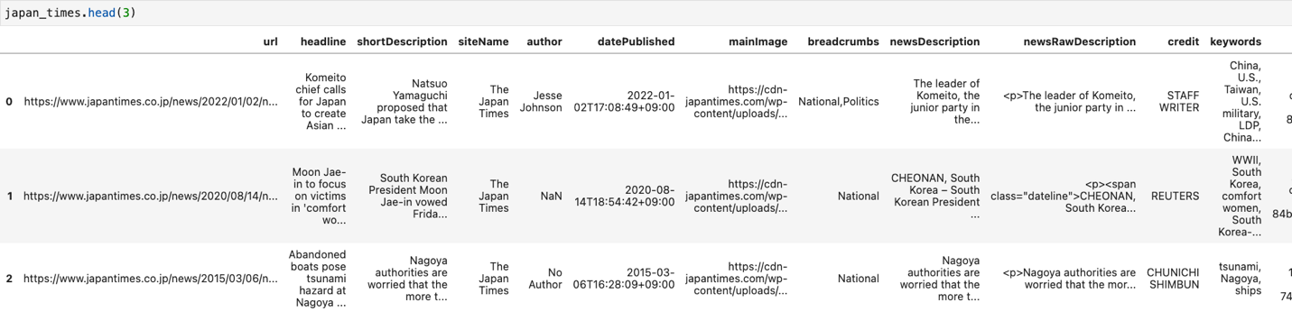

Figure 6: Japan Times news dataset fields description

The Japan Times news sample dataset size is 1.43 MB (compressed) with 14 fields. It contains sample data of news articles published between Feb 2002 - May 2022. Table 6 shows the BBC UK news dataset field description.

Table 6: Japan Times news dataset fields description

|  |  |  |
| --- | --- | --- |
| **Field** | **Type** | **Description** |
| url | URL | The web address or Universal Resource Locator for the webpage that contained the news article. This includes the protocol (http or https), host name, and subdomain. |
| headline | Varchar2 | headline of news article |
| siteName | Varchar2 | Name of the website |
| author | Varchar2 | The author(s) of the news article |
| datePublished | Date | Article published date |
| mainImage | URL | url of the main image |
| breadcrumbs | Varchar2 | Tagged keywords |
| newsDescription | Varchar2 | Briefing about the article |
| newsRawDescription | Varchar2 | Description in HTML format |
| credit | Varchar2 | Credit given for the article |
| keywords | Varchar2 | Keywords from the article |
| uniqId | Varchar2 | Unique id |
| scrapedAt | Date | Date on which data has been scraped |
| shortDescription | Varchar2 | A synopsis of what the article is about |

CNN news dataset

The Cable News Network is a multinational news-based pay television channel headquartered in Atlanta, United States. Crawl Feeds is the owner of the dataset, and it is available in public domain. Sample dataset of 7632 records is available for free. A larger dataset with more than 27K+ records last extracted on 22 July 2021 is available for a price of $54. CNN dataset is available in JSON format. Figure 7 shows sample CNN news dataset.

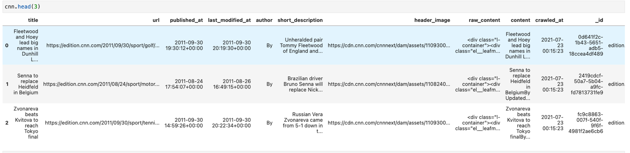

Figure 7: Sample CNN news dataset

The CNN news sample dataset size is 19 MB (compressed) with 12 fields. It contains data of news articles published by CNN from 30 September 2011 to 30 November 2012. Table 7 shows the CNN news dataset field description.

Table 7: Sample CNN news dataset field description

|  |  |  |
| --- | --- | --- |
| **Field** | **Type** | **Description** |
| title | Varchar2 | title of news article |
| url | URL | The web address or Universal Resource Locator for the webpage that contained the news article. This includes the protocol (http or https), host name, and subdomain. |
| published_at | Date | Article published date |
| last_modified_at | Date | Last modified date |
| author | Varchar2 | The author(s) of the news article |
| short_description | Varchar2 | A synopsis of what the article is about |
| header_image | Text/html | Link to access the header image |
| raw_content | Varchar2 | Description in HTML format |
| content | Varchar2 | Briefing about the article |
| crawled_at | Date | Date on which data has been crawled |
| _id | Varchar2 | Unique id |
| source | Varchar2 | Source of the news/article |

## Data Context

As mentioned, the datasets were obtained from Crawl Feed, an open-source resource that stores a variety of pre-collected datasets from the most popular sources across various industries and has already started crawling the websites that users want to source data from. These datasets have been customized to fit users' needs for data collection and archiving. Web scraping is the technique utilized in this collection. Data extraction from a website is referred to as web scraping. This data is gathered and then exported in a way that is more beneficial to the user. Whether it is an API or a spreadsheet.

The five diverse news collections were scrapped for this research and come from various locations throughout the world. The news channels chosen are from CNBC, Al Jazeera, BBC UK, Japan Times, and CNN news datasets because they cover a wide range of news topics, including sports, culture, business, politics, and the economy and are founded on unfolding current events. The data source is shown so that each URL leads to the webpage of a particular article on the publisher's website, where all the information displayed on that page can be retrieved.

All data was extracted in CSV or Excel spreadsheets except for those from BBC, CNN and Al Jazeera, which were produced as JSON. In terms of business news and real-time financial market coverage, CNBC is the industry leader. To searching and analyzing, the Crawl Feed team extracted more than 430K. Finished extraction on October 30, 2021. A television news channel called Al Jazeera English is broadcast all over the world by the Al Jazeera Media Network. June 2021 was the most recent scan of Al Jazeera news. A global news-based pay television network with its head office in Atlanta, Georgia, is the CNN Cable News Network.Crawl feed team is managing this to get the most recent data on July 22, 2021, and extracting about 27K records. More than 75K records make up the Japan Times News dataset. As of February 27, 2022, the last extraction was made. To gathering and disseminating news and current affairs, BBC News is an operational business division of the British Broadcasting Corporation. More than 1.17 million records were crawled by the internal Crawl Feeds team for research and analysis purposes.

## Data Conditioning

**Null/Missing Values validation check**

The primary datasets were then checked for missing/null values including empty cells, white spaces and ‘na’ strings as shown in Figure 8 using python.

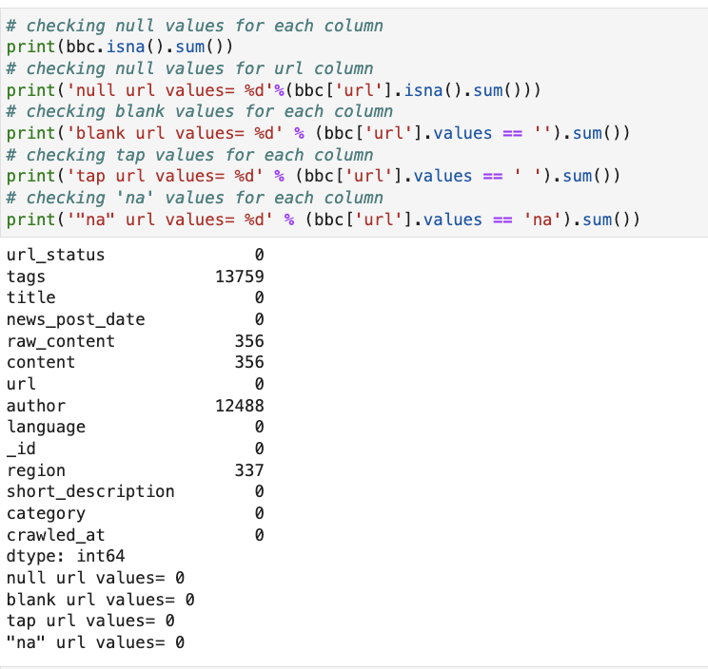

Figure 8: Checking null/missing values for one of the datasets

**Data Duplicity and validity of URLs Check**

It was a further inspection for duplicate rows that may exist (Figure 9) and to determine the accuracy, validity of the URLs (Uniform Resource Locator) was tested by python code (Figure 10).

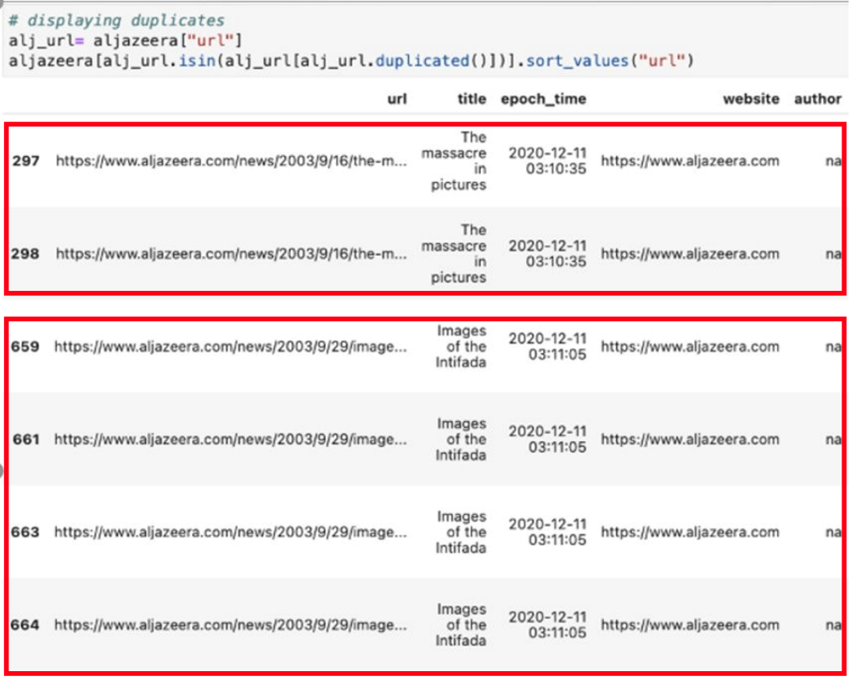

Figure 9: Identified duplicate rows for one of the datasets

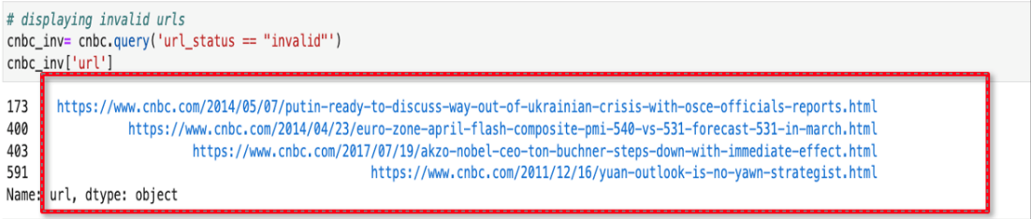

Figure 10: Identified invalid URLs for one of the datasets

**Data Consistency Check**

All datasets have been converted to Panda’s dataframe and then saved after cleaning into CSV files to have a uniform format to work on in later steps of the project. Figure 11 shows the step of saving one of the datasets dataframe to CSV file.

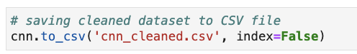

Figure 11: Saving dataset to CSV file to maintain consistency of files formats

## Data Quality Assessment:

Distinct factors that were considered for quality check include the completeness, consistency, uniqueness, conformity, and accuracy of data. All factors are explained below:

* Completeness: Each dataset was checked for null and blank values. If any of the rows in URL column had null values, the rows were dropped since without URLs there is no content to be extracted or tagged.
* Consistency: The main column that will be used in the project to extract tags is ‘URL’ column. Therefore, ‘URL’ column consistency was checked to save the complication of using different kinds of transformation techniques when feeding the model. ‘URL’ column is static for all datasets.
* Uniqueness: For uniqueness, the rows of datasets were checked for duplicity with more focus on the URL columns. Only six were identified as duplicates, one in CNN and five in Aljazeera, in which were dropped.
* Conformity: Considering the dataset is a combination of various news articles the only thing to report on conformity is the html structure of the webpages that vary slightly from one network to another considering each one has their own way to display their webpage.
* Accuracy: The validity of the URL was tested by confirming if the website exists or not using urllib package modules. 2065 URLs were found to be invalid in BBC dataset and five in CNBC and. were dropped as a result.

## Other Data Sources

DCAT is another data source that we referenced for the purpose of setting our standard baseline for naming field names of tags in the catalog record.

**DCAT**

World Wide Web Consortium’s (W3C) Data Catalog (DCAT) [Provide URL citation] vocabulary is an RDF vocabulary designed which defines the schema and provides examples for its use. Also, it facilitates interoperability between data catalogs published on the Web. A data catalog conforms to DCAT if data is organized into datasets, distributions, and data-service. DCAT enables a publisher to describe datasets and data services in a catalog using a standard model and vocabulary that facilitates the consumption and aggregation of metadata from multiple catalogs. This can increase the discoverability of datasets and data services. It also makes it possible to have a decentralized approach to publishing data catalogs and makes federated search for datasets across catalogs in multiple sites possible using the same query mechanism and structure. Aggregated DCAT metadata can serve as a manifest file as part of the digital preservation process.

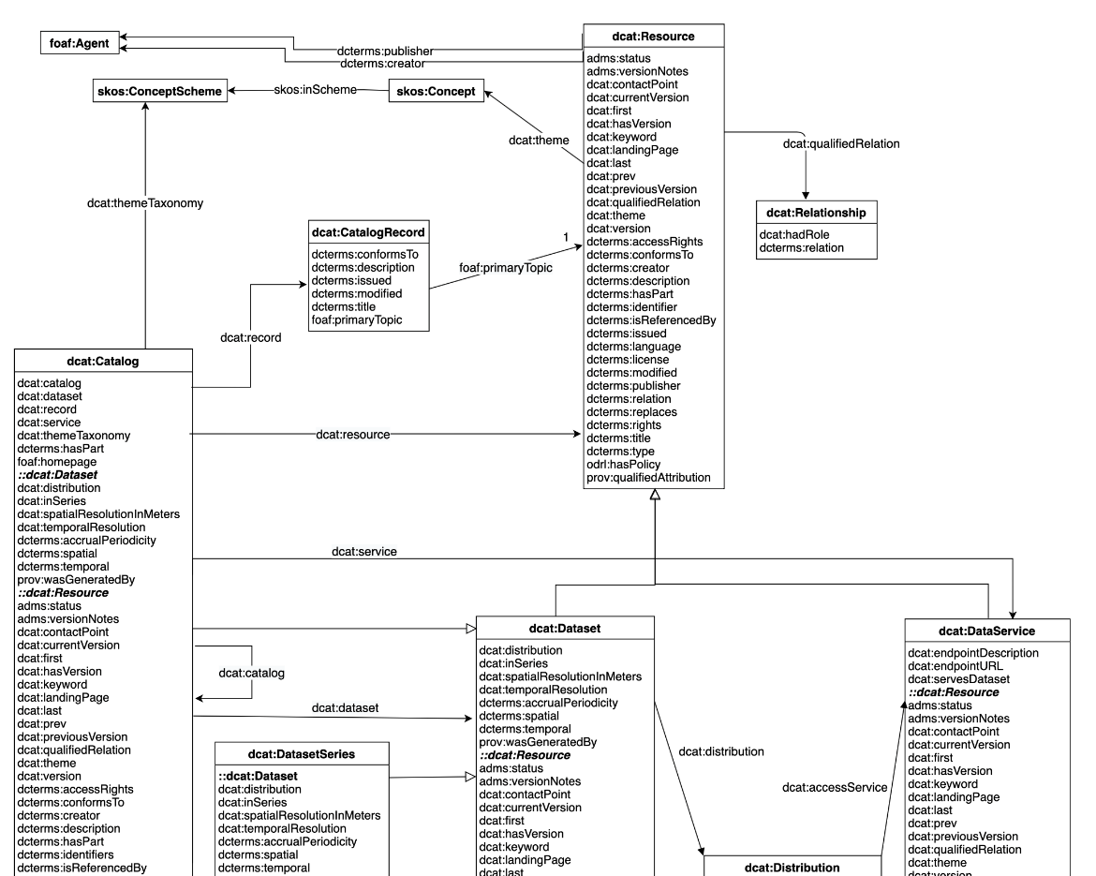

Figure 12: DCAT Scope

# Analytics and Algorithms

This project is primarily focusing on automating the process of tagging data for preparing a data catalog. To address this need we are using multiple python packages and applying analytics and algorithms to tag the data with accuracy. The model selected for our analysis is LDA (Latent Dirichlet Allocation) which is a statistical model for finding topics from the text.

## System Environment

The Data Bees team utilized JupyterLab on Anaconda as the main development workplace environment. For each stage of the three project stages, a python notebook was developed. A script for cleaning datasets, another for extracting data, and the last one for modeling. The codes were run locally on laptops roughly ranging with specs such as Intel i7 processor, 16GB RAM 128GB SSD and 1TB HDD. For sharing files, a GitHub repository was used to help store and keep track of the project's progress. In addition, various python packages such as pandas, os, json, numpy, beautifulsoup, urllib, spacy, and re.

## Solution Schematics

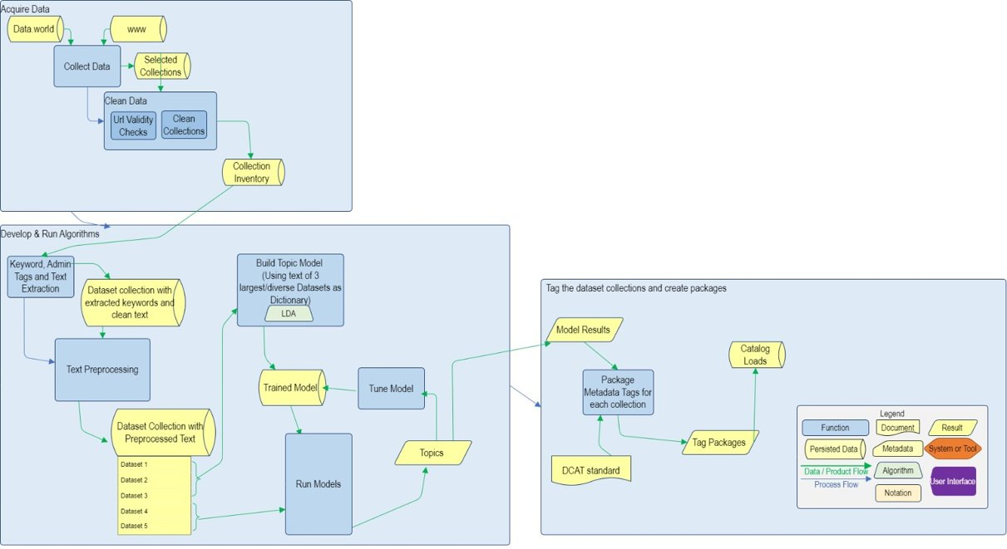

Figure 13: Solution Schematics

## Project Analytics Steps

## Step 1: Extract clean text, title, and published date

The extraction of clean text, title, and published date is done using several python packages which include:

1. **urllib – URL handling modules**

The ‘urllib’ package collects several modules for working with URLs and to access, and interact with websites using their URL’s (Uniform Resource Locator).

* [urllib.request](https://docs.python.org/3/library/urllib.request.html#module-urllib.request) for opening and reading URLs
* [urllib.error](https://docs.python.org/3/library/urllib.error.html#module-urllib.error) containing the exceptions raised by [urllib.request](https://docs.python.org/3/library/urllib.request.html#module-urllib.request)
* [urllib.parse](https://docs.python.org/3/library/urllib.parse.html#module-urllib.parse) for parsing URLs
* [urllib.robotparser](https://docs.python.org/3/library/urllib.robotparser.html#module-urllib.robotparser) for parsing robots.txt file

1. **Beautiful Soup**

It is a Python library for pulling data out of HTML and XML files. It is used in parsing HTML, creates a parse tree for parsed pages that can be used to extract data from HTML.

1. **Trafilatura**

Trafilatura is Python package and command-line tool which seamlessly downloads, parses, and scrapes web page data: it can extract metadata, main body text and comments while preserving part of the text formatting and page structure. The output can be converted to different formats.

1. **htmldate**

This python library is used to extract publication dates from web pages. It helps in Finding the original and updated publication dates of any web page. From the command-line or within Python, all the steps needed from web page download to HTML parsing, scraping, and text analysis are included.

**Functionality**

After checking all the null and duplicate values along with expired links we have verified the data quality of the datasets. To proceed further with metadata extraction, first the URL content is read. Using ‘Beautiful Soup’ library the paragraph and title from the HTML content are extracted and 2 columns ‘extracted_cleaned_text’ and ‘extracted_title’ are created, respectively. Finally, the ‘find_date’ library is used to extract the date from the HTML content and is saved in a newly created column ‘extracted_published_date’ as shown in Figure 14.

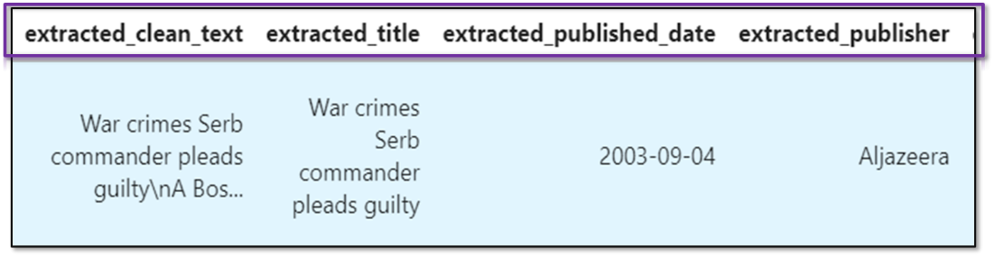

Figure 14: Extracting title, published date and clean text from URL

## Step 2: Extract entity keywords – Person, Location, Organization

The ‘spaCy’ python package is used for the process of keyword extraction. The ‘spaCy’ package is an entity recognizer which is used to recognize named entities in text into pre-defined categories such as the names of persons, organizations, locations etc. It is a free and open-source library for Natural Language Processing (NLP) in Python with a lot of in-built capabilities. It is used in analyzing unstructured textual data produced at a large scale.

**Functionality**

After the paragraph, title, and date extraction, the process of extracting keywords is carried forward. Three categories of entity tags are generated based on Person, Location and Organization entities as identified by the entity recognizer into the columns extractedkeyw_per, extractedkeyw_org and extractedkeyw_pla respectively as shown in Figure 15.

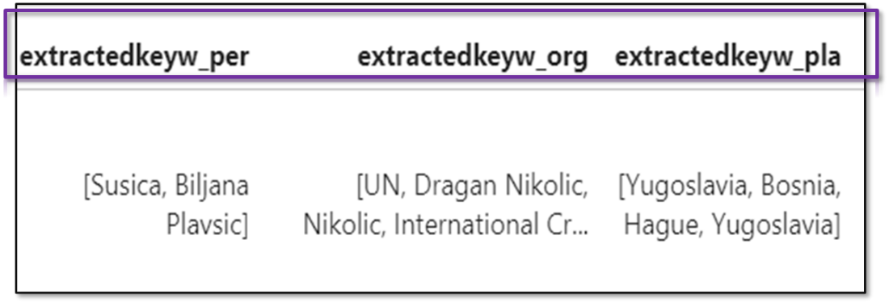

Figure 15: Extracting named entity tags

## Step 3: Identify and tag topics from extracted clean text using LDA

The model selected for our analysis is LDA from the python Gensim package. Latent Dirichlet Allocation is a topic modeling algorithm to extract hidden topics from large volumes of text. Topic modeling is used to automatically organize and summarize documents based on the discovered themes. For example, let us say a document contains the topic related to football or cricket, and user queries for ‘sports’ in catalog, they might find this document as its covering topics related to sports. The model finds the relevancy of query to documents based on topic without going through the entire document. This unsupervised classification technique extracts the percentage contribution of each topic in a bunch of text showing which topic is discussed the most in the documents. Each document is a collection of topics in a certain proportion and each topic is a summation of the most dominant keywords. It extracts all main keywords from a document and then clusters them based on similarity and groups them as one topic. A document can be a part of multiple topics and each topic can be covered by many documents. It all depends on which cluster each data point belongs to. This algorithm addresses some challenges including how to find decent quality and optimal quantity of topics. In our case this text is the clean text extracted from url content.

The packages used are Gensim (for pre-processing raw texts), spaCy (for lemmatization), pyLDAvis (for visualization). To consume this text for our model LDA we need pre-processing (cleaning and transformation) of data which includes removing emails, new lines and extra spacing. The process can be broken down into the following steps:

1. Convert sentences to a list of words (tokenization) after removing punctuation and irrelevant characters
2. Remove stop words (e.g., the, is, and, etc. which carry very less useful information)
3. Creating bigrams and trigrams which are two and three most frequently occurring words together respectively e.g.: ‘story highlight’, ‘free kick’ etc.
4. Stemming, which converts words to their basic forms/stems like eat, eating, ate are different forms of the same word and lemmatization which uses the context of words (e.g., hopes -> hope).

The image below shows an example of how the text data in the dataset is converted by the preprocessor script (Figure 16).

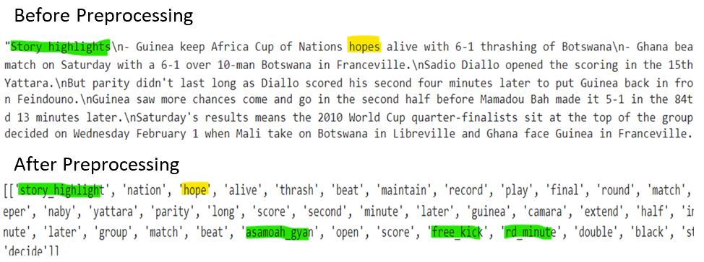

Figure 16: Text before and after preprocessing

Once the lemmas are generated, dictionaries and corpus are created for the LDA model's inputs. Corpus is the mapping of word id to word count in an article. LDA assigns a random topic to each word in the corpus of documents we provided. For example, if we need five topics, it will set a number from one to five for each word and then calculate the document to topic count. So, for each topic, it will count the number of words assigned for a given document. It also counts how many times a word is associated with a topic. After the random initialization, we must convert the model to a point where words signify the topic. So, it will go on reassigning the topic of each word based on probability calculation at every pass until it converges. The calculations are made based on how much the document likes each topic and how much each topic likes a word. This process is repeated for all the words in the corpus of documents in one pass and iteratively keeps changing topics until the point of convergence is reached. After the model is converged, it sorts all the words based on the count and gives out a probability score in descending order.

Perplexity and coherence are the measures to check the goodness of a model. Lower perplexity and higher values of coherence are what we need.

**Implementation**

Following the extraction of metadata tags such as location, date and so on the extracted clean text is subjected to topic modeling with the intent to identify dominant topics present in the dataset and classify them based on the same to enable data cataloging. First the article texts in the datasets are converted into clean tokens through a preprocessor script, ready to be fed into the LDA model. A master dictionary is created with around 40751 tokens, the word types of which are generated from the text of the 3 most diverse and largest datasets in the inventory – CNN, Aljazeera and BBC as shown in Figure 17.

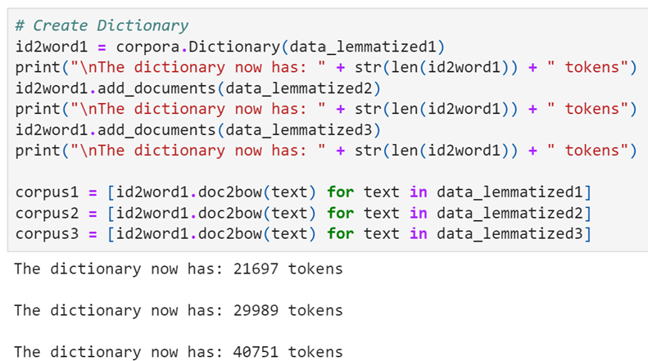

Figure 17: Master Dictionary created using 3 largest and most diverse dataset

This dictionary is used as vocabulary reference to build the corpus of all the datasets in the inventory. The LDA model is first built with random and default numbers for hyperparameters as advised in the Gensim documentation using Aljazeera corpus with 8 as the number of topics to be identified as input (Figure 18).

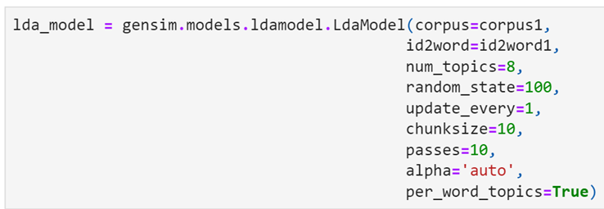

Figure 18: Initial LDA model using Aljazeera corpus

From over 3400 + articles, when asked to identify 10 dominant topics, the model provides 10 collections of keywords that occur together as topics with each keyword having its own weightage in that collection as shown in Figure 19.

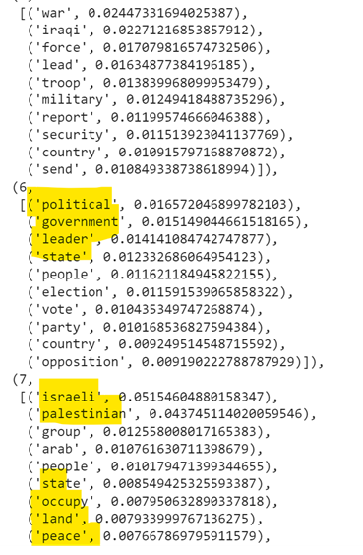

Figure 19: Identifying dominant topics and its keywords using the model (Aljazeera)

It is seen that distinct collection of keywords related to some significant topics appear together such as

* ‘israeli, ‘palestinian’, ‘occupy, ‘land’ and ‘peace’ - could be translated as related to Israel-Palestine conflict;
* ‘political’, ‘government’, ‘election’ and ‘leader’ - seems to be synonymous with Politics;

And similarly other topics are identified. Two metrics are used to measure how good the model is – coherence and perplexity which turn out to be –8.656 and 0.409 for this initial model, respectively as shown in *Figure 20.*

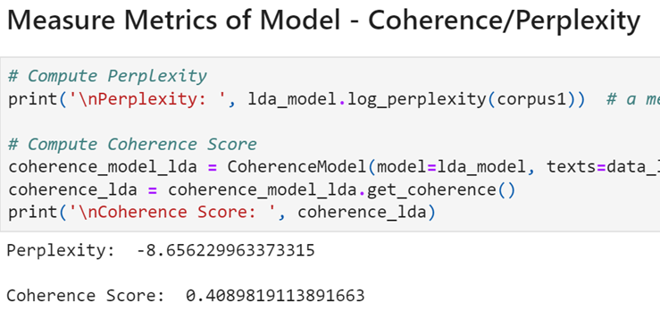

Figure 20: Coherence and perplexity of the gensim model

Now these are the results of the first trial with untuned parameters of the model. The results are visualized as a distance map to see the inter and intra-cluster distances between the assumed topic clusters as shown in Figure 21 to get an understanding of which clusters are related and unrelated and an idea of how refined the model is. The quadrants separate the topics into different domains as wide apart as possible.

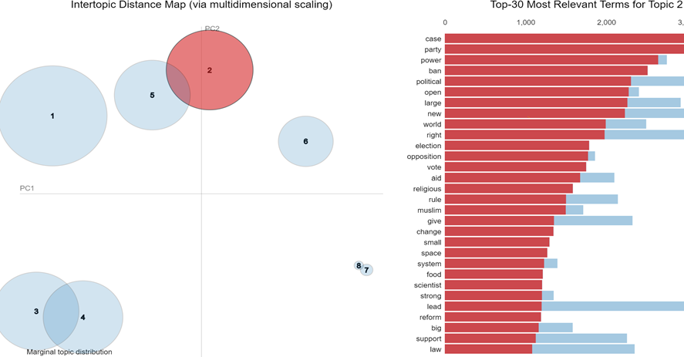

Figure 21: Intertopic Distance Map showing topic clusters with corresponding keywords

Now to identify the optimum number of topics the mallet’s version of LDA is used in tandem for comparison and the initial coherence turned out to be 0.45

The same corpus and dictionary are used to run the model but this time iterating over a range of numbers of topics for the model to identify rather than just one input. The resulting models’ coherence scores are compared using a line plot to see the most optimum number of topics to feed to the model for identifying in the given dataset as shown in Figure 22. The model’s coherence keeps increasing with topics and to avoid over the problem of classification/overfitting the tuning algorithm is restricted to 10 topics as maximum.

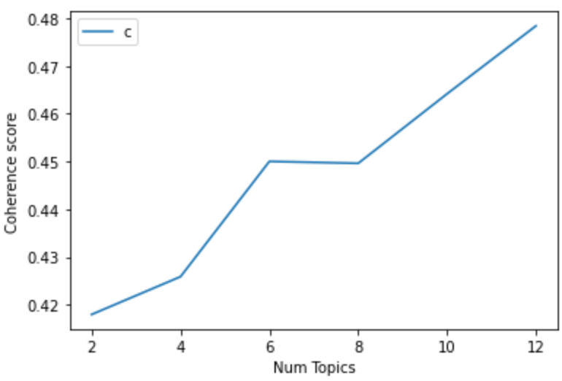

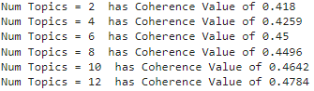

Figure 22: Finding optimal number of topics to classify the Aljazeera dataset

It can be inferred from the plot and the subsequent list generated from the same that 10 is the optimum number of topics to feed as input for the model to distinguish with a coherence score of 0.464. This is an improvement over the 0.409 score the previous model provided. Note that the model shows a higher coherence with 12 topics which isn’t considered as we restricted the tuner to 10 to prevent over classification. Now the model is run again with the optimum number of topics and each article is tagged with what dominant topic it talks about allowing to create groups based on the topic number as shown in Figure 23*.*

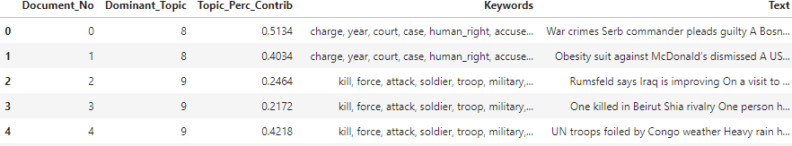

Figure 23: Creation of topic clusters by rerunning the model with new-found optimal number of topics

Here the ‘Document_No’ corresponds to the index id of the article being tagged, ‘Dominant_Topic’ is the index id of the topic generated by the model and ‘Topic_Perc_Contrib’ represents the percentage contribution of the dominant topic in that specific article. Now, to get an idea for the best descriptor of the topic, the article best represented by the topic is identified as shown in Figure 24. Going through that article gives an example of what the topic is all about which can help in deciding what label can be given for the topic.

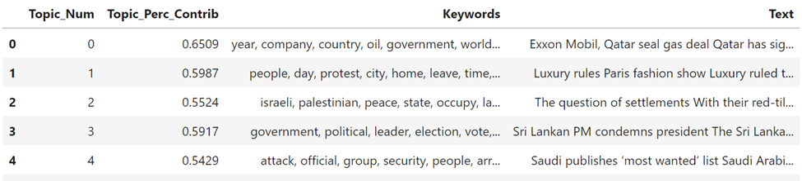

Figure 24: Identify the best descriptor for each topic collection

After this, a dictionary is manually created to map topic index to tags or labels and then the label along with the topic keywords are appended to the original dataframe which has all the other extracted keywords as shown in Figure 25.



Figure 25: Adding identified topics to the Aljazeera Dataset for classifying them

Then the dataset is grouped into classifications based on the identified topics, considering it as the best descriptor for that collection. For example, Aljazeera is grouped into ten collections based on the topics identified using the LDA model as shown in ‘Figure 26‘.

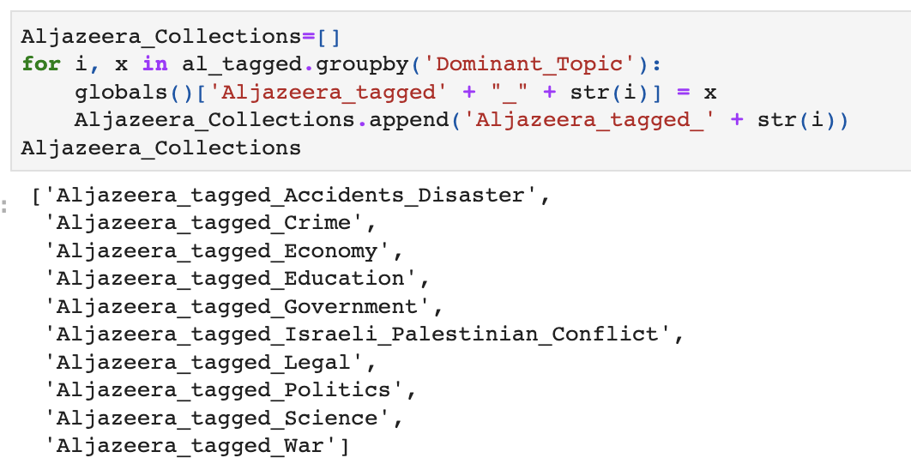

Figure 26: Group collections as individual dataframes

The grouped collection is fed into the tags counter function to receive an output of the most frequently occurring terms for each of the extracted entity keywords (person, organization and location). Also, the published date range is collected to indicate the time period of the articles. This output is used to add a metadata tag for the collection’s record in the catalog. A sample of the top three tags of accidents and disaster collection and published date period is shown in Figure 27.

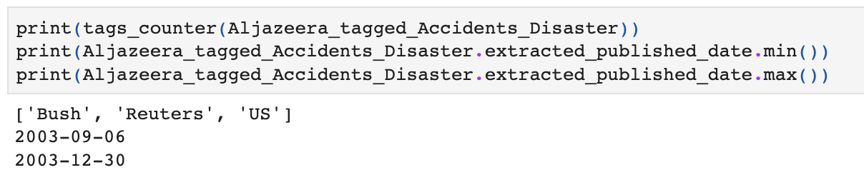

Figure 27: Roll-up Collections via Keyword Frequency and Tag Them

The last step is updating the packaged tags into a dataframe mimicking a catalog record with field names referencing the DCAT vocabulary so the collection record would look as shown in Figure 28, when it is entered as a record in the Catalog.

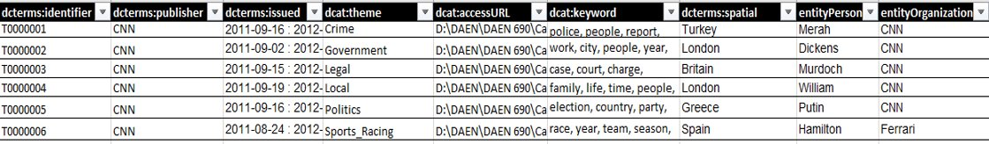

Figure 28: Final Tagged Collections in a Catalog

# Visualization

## Visualizations for Exploratory Data Analysis

Visualization using word cloud: To offer a visual representation of a text present in our datasets, the word cloud is created. This word cloud is generated from the clean title extracted from html content of URL's. These collections of words are pulled from the datasets to get an insight of how our tags could look like. These word clouds give us an estimate about what the text in dataset looks like and what it talks about. In these visualizations, the more times a word occurs in the dataset, the larger it appears. Unstructured text data can be visualized easily with word clouds to reveal patterns and trends.

The preprocessing of each dataset is mentioned in section 3 and these word clouds are generated to learn more about the areas the datasets addressed. It's imperative to keep in mind that the word cloud does not show the tags, it just shows the most appeared words in the text.

### CNN Dataset

From words like win, cup, Madrid, open, final, we inferred that topics related to international sports are primarily highlighted in the CNN dataset (Figure 29). Politics, Entertainment, Media, Sports, Travel, and areas related to those subjects can also be found. CNN includes several geographically specific news too, including those for the US, Europe, Asia, and the World.

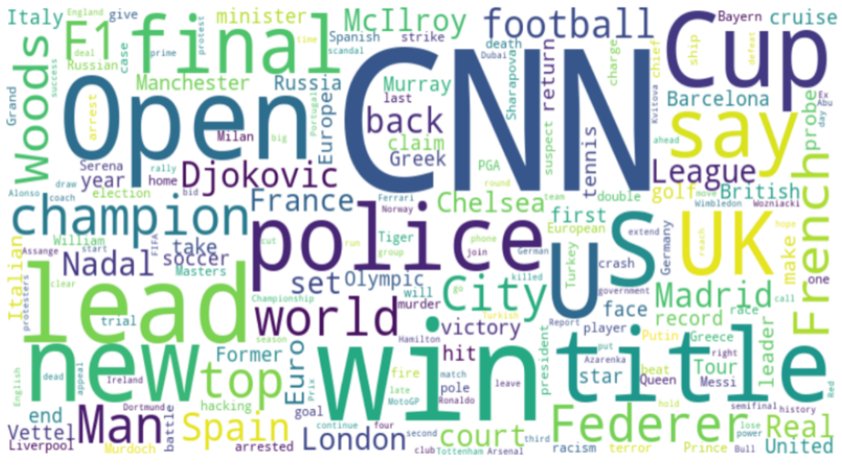

Figure 29: Word Cloud from CNN news dataset

### BBC News Dataset

The BBC UK dataset trends mostly focus on local and regional insights along with global and UK news (Figure 30). Entertainment, business, science, technology, and health news are among the topics covered. In short, this news dataset covers a wide variety of topics.

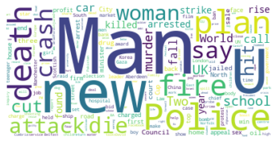

Figure 30: Word Cloud from BBC UK dataset

### Aljazeera News Dataset

The Aljazeera English news dataset trends mostly focus on reporting and covering the Middle East and African countries, including Palestine Israel conflict as well as worldwide affairs in crime (Figure 31). The trends report discusses evaluations of the media, money, politics, and crime.

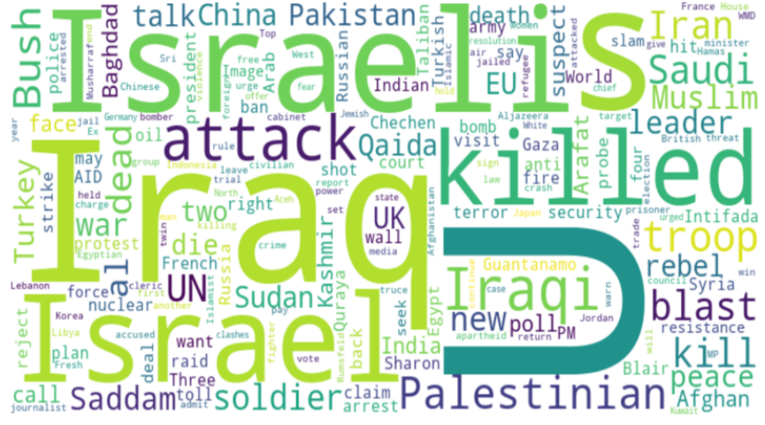

Figure 31: Word Cloud from Aljazeera English news dataset

### Japan Times News Dataset

Trends in the Japan Times news dataset mostly focus on news of East Asian countries like China, Japan, Mongolia, North Korea, South Korea, and Taiwan. Politics, Opinion, Health, Entertainment, Media, War, Technology, Travel, and Living are the subjects that can be found in this dataset (Figure 32). In comparison to the CNN news dataset, this dataset features fewer location components, such as those for US, European, and Asian nations.

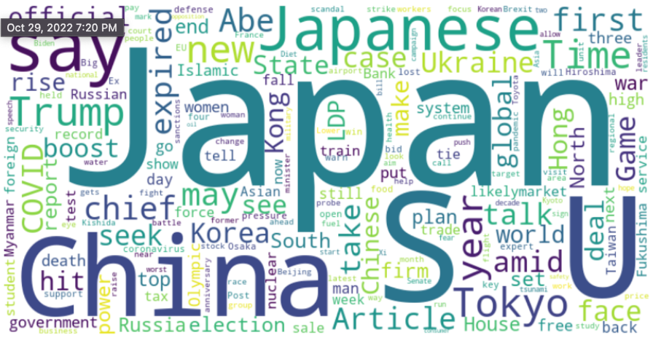

Figure 32: Word Cloud from Japan Times news dataset

### CNBC News Dataset

CNBC News mostly focuses on business and the stock market. As shown in Figure 33, the stock topic holds the majority of the articles. Market, banking and trade are shown the most frequently, which indicates that CNBC News is all about business.

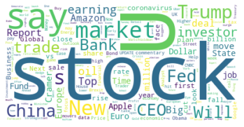

Figure 33: Word Cloud from CNBC news dataset

## Visualization for preprocessing text:

During the pre-processing steps, once the data is converted from sentences to list of words, they are used to create n-grams. N-grams are simply sequence of tokens or words which show the important words in a document. N-grams are used to define how many numbers of words as used as observation points. To create n-grams we used Scikit-learn's CountVectorizer [function](https://scikit-learn.org/stable/modules/generated/sklearn.feature_extraction.text.CountVectorizer.html). The below procedure is a case example for CNN dataset:

### Unigrams

Unigrams are single words or singly worded phrases. The most frequent 20 words are extracted from the text which are shown in Figure 34. These unigrams are single words that occur most in the document. The word ‘the’ is mostly used in CNN dataset based on its count.

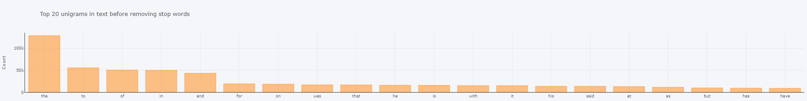

Figure 34:Word Cloud from CNBC news dataset

But the stop words are of no use as they don’t add any value while extracting meaning out of data. So, stop words are removed and again unigram is plotted. The word ‘year’ turns out to be the most occurring word in CNN dataset (Figure 35).

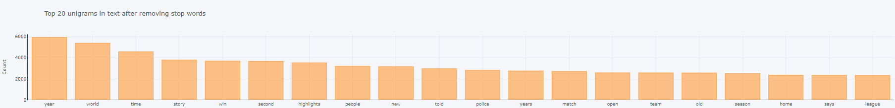

Figure 35: Top 20 unigrams after removing stop words

### Bigrams

Similarly, bigrams are the two worded phrases like ‘water bottle.’ They are the two most frequently occurring words in a text. Without removing stop words, ‘of the’ is most occurred bigram in CNN dataset (Figure 36). After initial processing of data, a model and then function for bigram is created and the output of that function is used to create corpus, which is fed as input to LDA model.

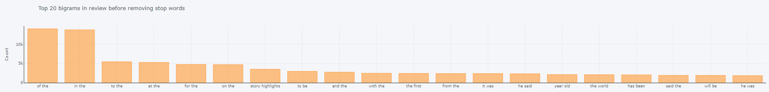

Figure 36: Top 20 bigrams before removing stop words

On the same lines, stop words are removed and bigrams are generated again which have more information to feed into the LDA model. After removing stop words, ‘story highlights’ turns out to be the most frequent bigram according to the count (Figure 37).

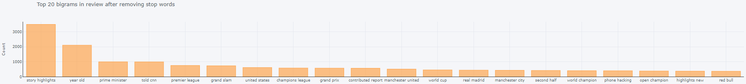

Figure 37: Top 20 bigrams after removing stop words

### Trigrams

Trigrams are three phrased words like ‘district of Columbia’ that occur together frequently. Figure 38 shows the top 20 trigrams before removing stop words. ‘One of the’ is the most frequent word in CNN dataset.

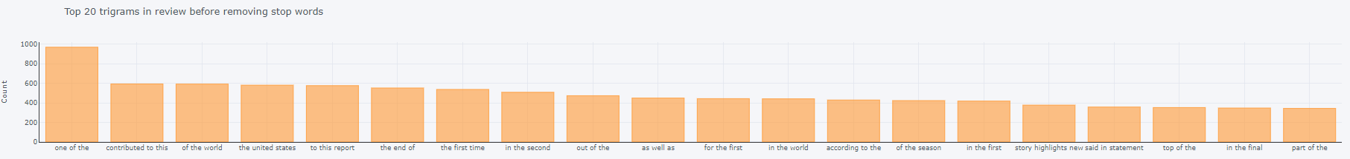

Figure 38: Top 20 trigrams before removing stop words

Now low-level information providing words – stop words, are removed so more vital information in the text can be focused on. So, after removing stop words, ‘story highlight new’ is the most recurrent trigram in given dataset (Figure 39).

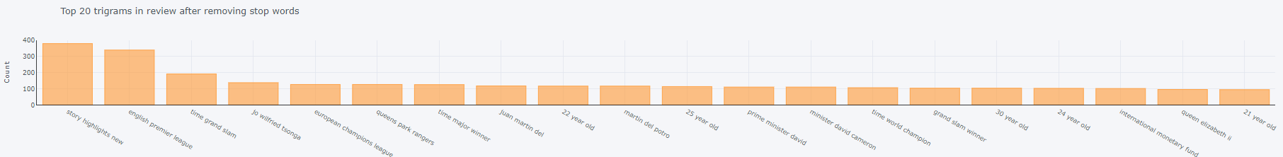

Figure 39: Top 20 trigrams after removing stop words

Similarly, the results for unigram, bigram, and trigrams for each of the other datasets are also obtained as shown in Appendix D.

## Visualizations for Topic Modeling

For all the datasets the optimal number of topics generated by LDA mallet model is identified to be between six to eight. These topics are clear, segregated and organize the dataset in the best possible manner. These visualizations are one of the best ways to summarize the datasets by showing the words, topics; detecting events and creating storylines.

### Topic Modeling Results for CNN

After exposing the CNN dataset to LDA model, the optimal number of topics for CNN dataset is found to be six. Below is the intertopic distance map for the optimal number of topics (Figure 40).

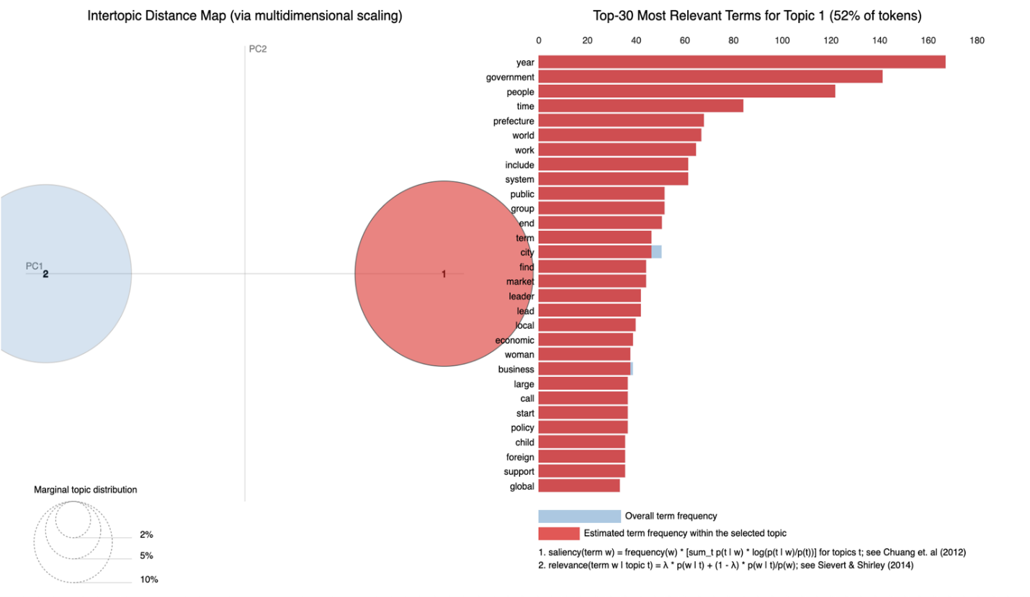

Figure 40: Intertopic Distance Map for CNN

The subplot visualization below shows those topics (from 0 to 5) with their keywords (Figure 41). The keywords are displayed as overlapping bar graphs of the word count and their weights. It shows which keyword is repeated mostly in text by its count and for each keyword weight is assigned to it based on the importance factor.

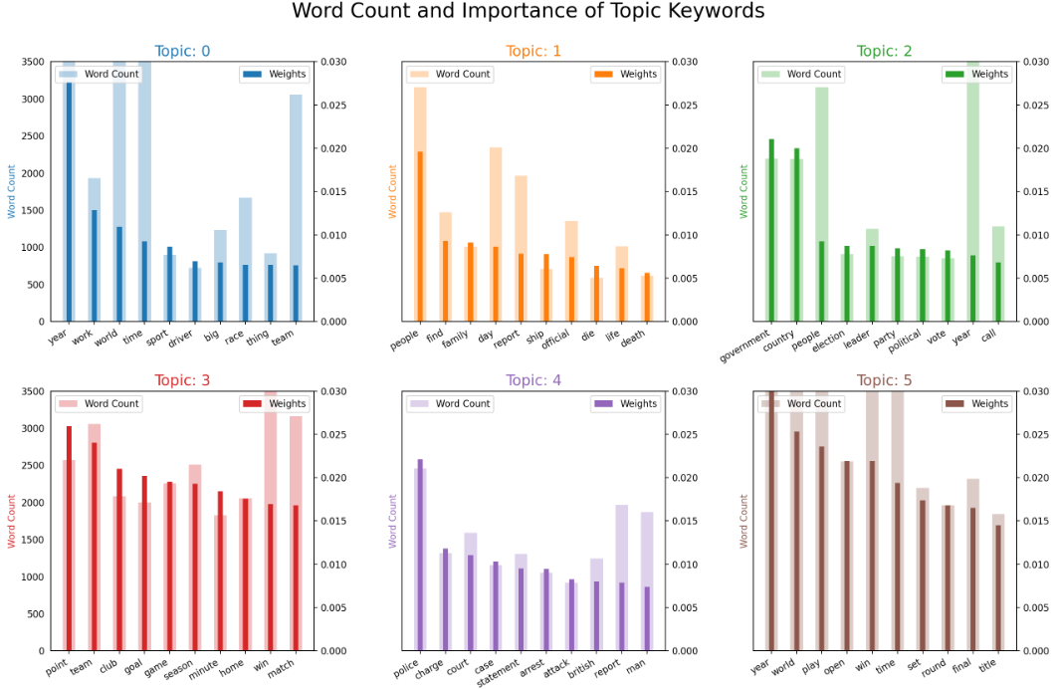

Figure 41: Word Count and importance of Topic Keywords

After these steps, a dictionary is manually created to map topic index to tags or labels. Below visualization shows the same six topics that are shown above but with tags assigned to each topic (Figure 42). The tag’s found from CNN dataset are ‘sports- racing,’ ‘accidents/fatalities,’ ‘politics,’ ‘sports- soccer,’ ‘legal’ and ‘sports –tennis.’ It is inferred from this that the CNN dataset mostly talks about sports articles. The keywords are shown with distinct colors for each tag. The bigger the keyword is, the more weightage it has. For example, in tag ‘sports- Racing’ ‘year’ has the highest word count and weightage, and hence has the largest size.

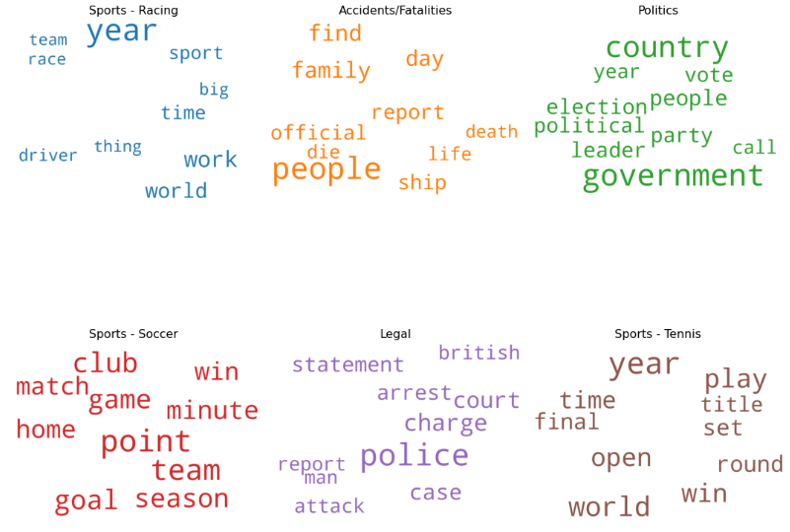

Figure 42: Labeling of Topics based on Keywords

### Topic Modeling Results for BBC

After using the LDA model, the probabilistic topics extracted from BBC dataset are eight. Below is the intertopic distance map for the optimal number of topics (Figure 43).

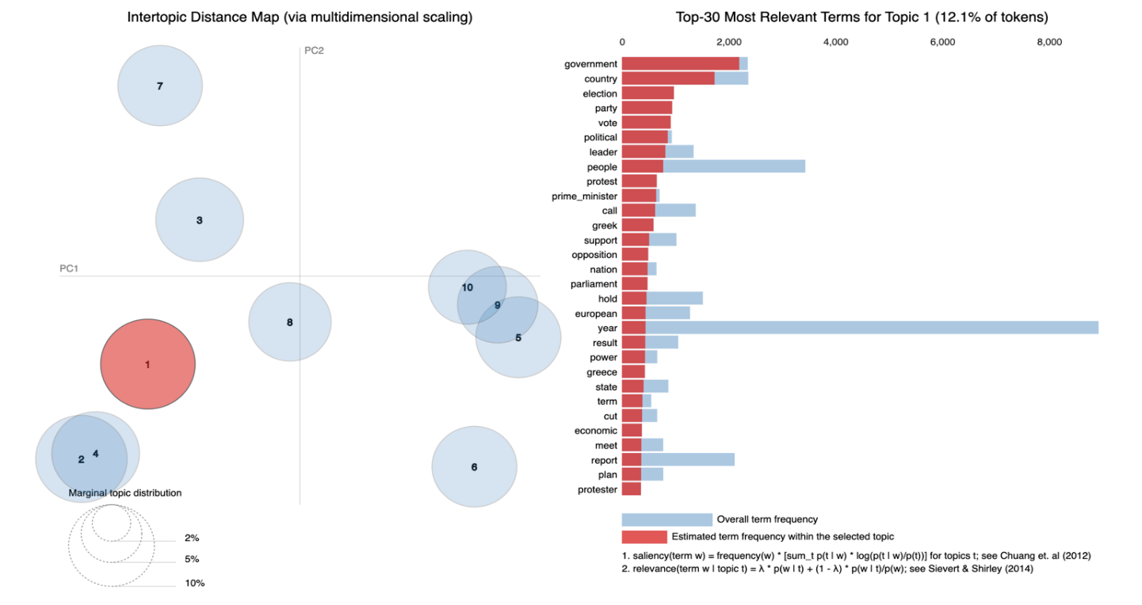

Figure 43: Intertopic Distance Map for BBC

These topics along with their top keywords are depicted in the visualization below (Figure 44). The top eight topics and the top 10 keywords within each topic, and their coherence scores were all extracted from the corpus fed into the LDA.

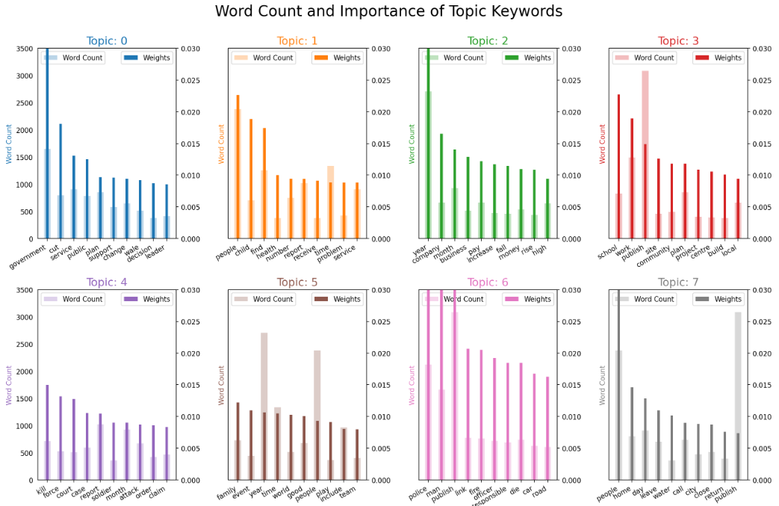

Figure 44: Word Count and importance of Topic Keywords

Below visualization shows that BBC dataset consists of a wide variety of distinct topics (Figure 45). The Topic 0 keywords appear to point to the "Finance/Economy", so it is tagged as “Finance/Economy". Topic 1 has keywords related to "politics", the other generated tags are “Crime”, “Sports and entertainment”, “accidents/disasters”, “fatalities”, “government” and “health”. These tags have been manually mapped from index number.

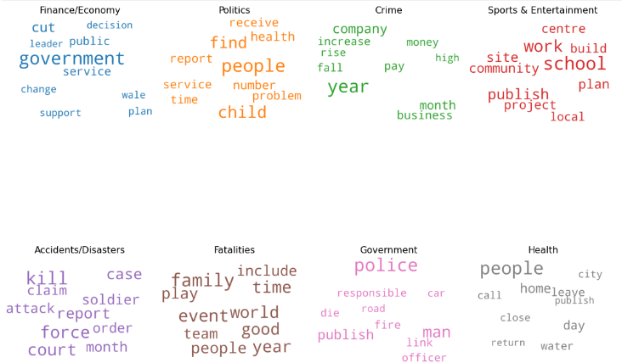

Figure 45: Labeling of Topics based on Keywords

### Topic Modeling Results for Al-Jazeera:

After identifying optimal number of topics as 8, they’re retrieved from the Al-Jazeera dataset using the LDA model. Below is the intertopic distance map for the optimal number of topics (Figure 46).

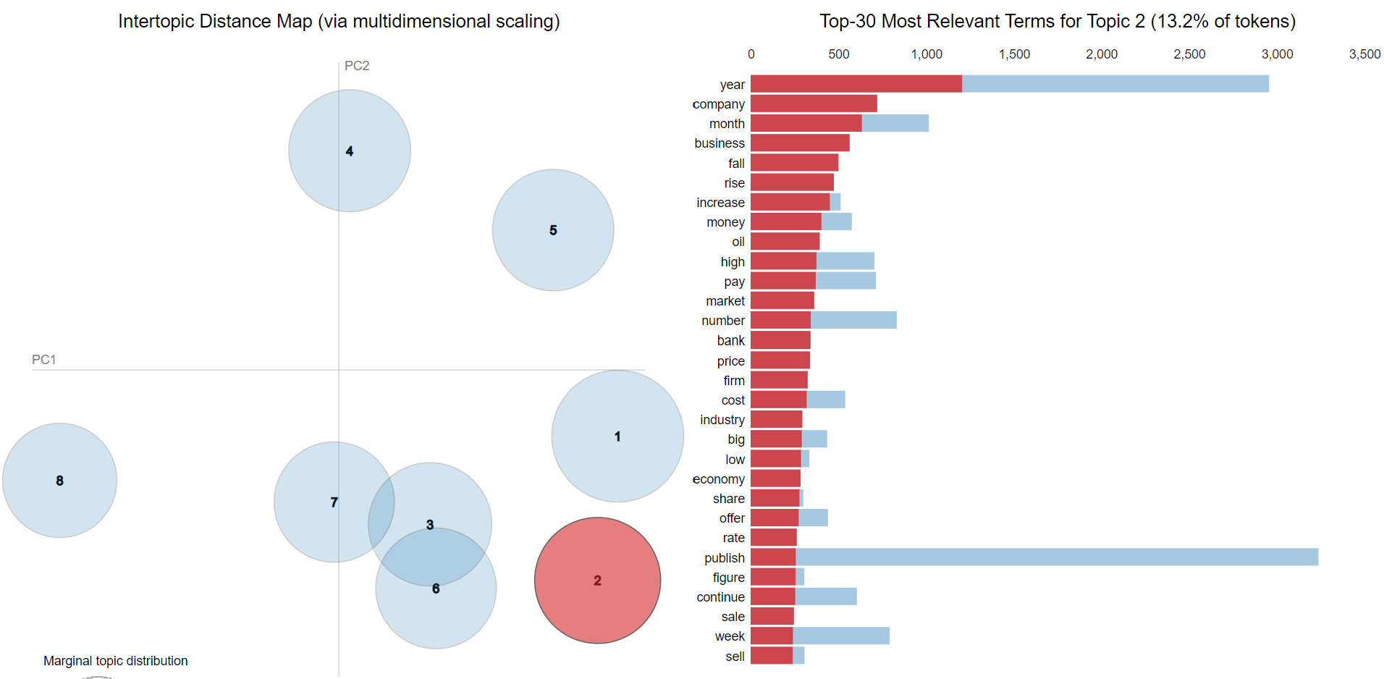

Figure 46: Intertopic Distance Map for Aljazeera

The visualization below shows these topics and their most recurring keywords (Figure 47). The corpus input of the LDA was used to extract the top eight topics and the top 10 keywords within each topic. The keywords that were closest to each other were grouped under one topic. Each keyword is shown with two parameters as relative frequency in this dataset and their weightage. For example, in topic 2, keyword ‘people’ has the highest word count and weightage.

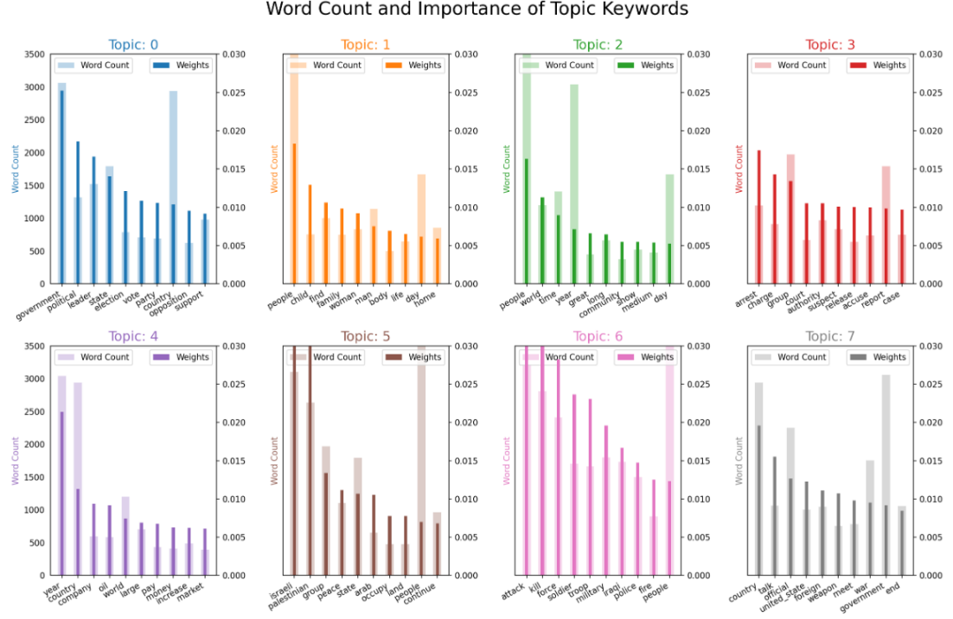

Figure 47: Word Count and importance of Topic Keywords

These topic numbers were mapped manually to tags which includes politics, family/education, international, legal, economy, Israeli-Palestinian conflict, violence/war, and foreign affairs/politics (Figure 48). From tags and keywords, we inferred that Aljazeera dataset mostly talk about middle Asian countries' news and affairs.

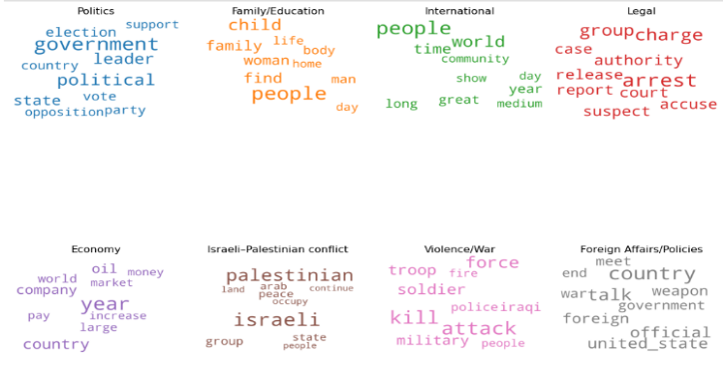

Figure 48: Labeling of Topics based on Keywords

### Topic Modeling Results for Japan Times

The optimal number of topics for Japan times turned out to be six. Below is the intertopic distance map for the optimal number of topics (Figure 49).

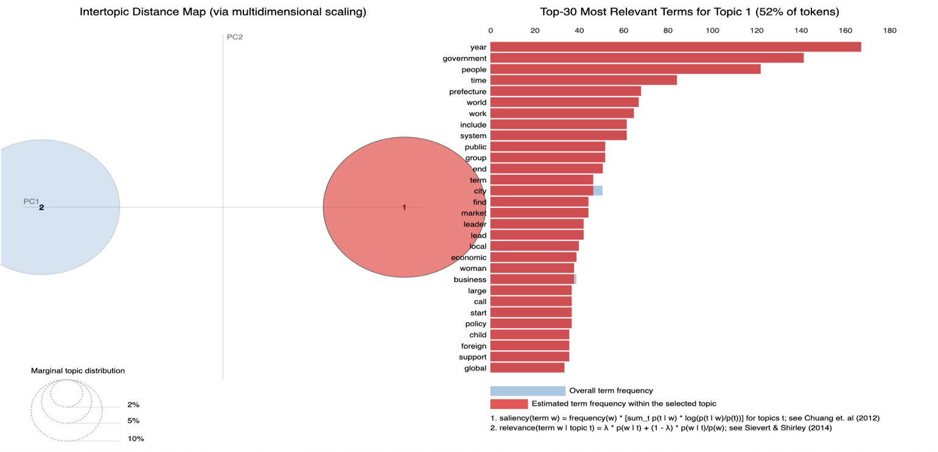

Figure 49: Intertopic Distance Map for Japan Times

These topics with their keywords are shown in visualization (Figure 50). In topic 0, a bigram was also noticed as Prime Minister, these are the two words that occur together frequently in the document and if separated they will have a different to no meaning. In topic 0, year is the keyword with the most word count and weightage.

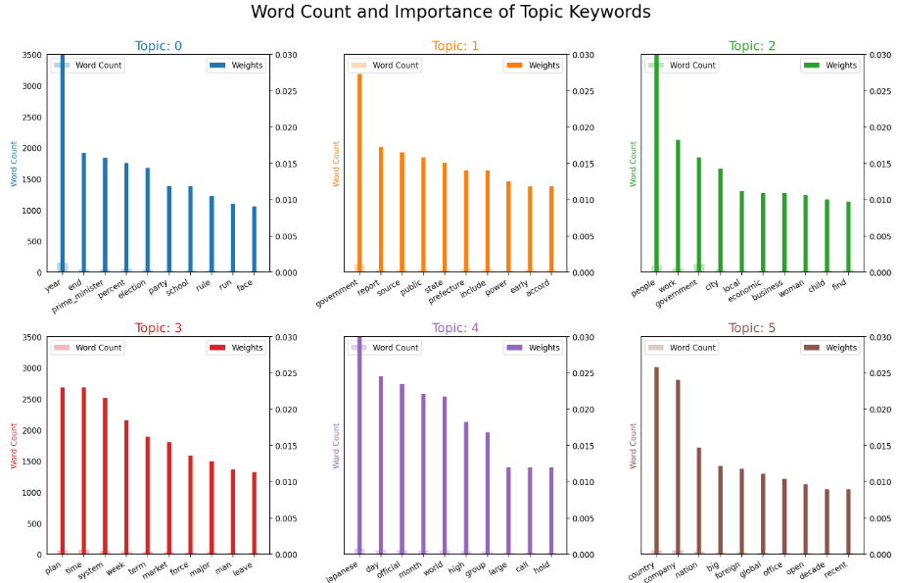

Figure 50: Word Count and importance of Topic Keywords

The topics are mapped to the tags like elections, government, international events, finance, politics, and national events manually. In topic 0, ‘year’ is the keyword with the most word count and weightage as the bar is highest for it. On the same lines, the below visualization showed the keyword ‘year’ the biggest as it has the most count and weightage (Figure 51). The keywords for each of the topics are shown in varied sizes based on their importance in the text.

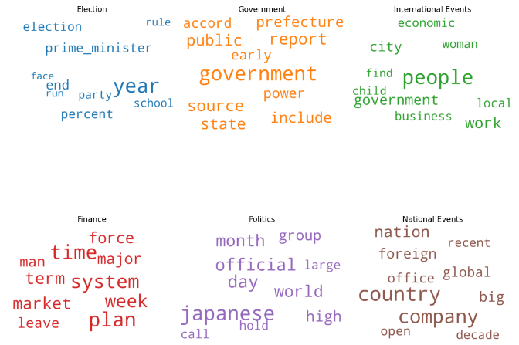

Figure 51: Labeling of Topics based on Keyword

### Topic Modeling Results for CNBC

The optimal number of topics for CNBC dataset was determined as ten using the LDA model. Below is the intertopic distance map for the optimal number of topics (Figure 52).

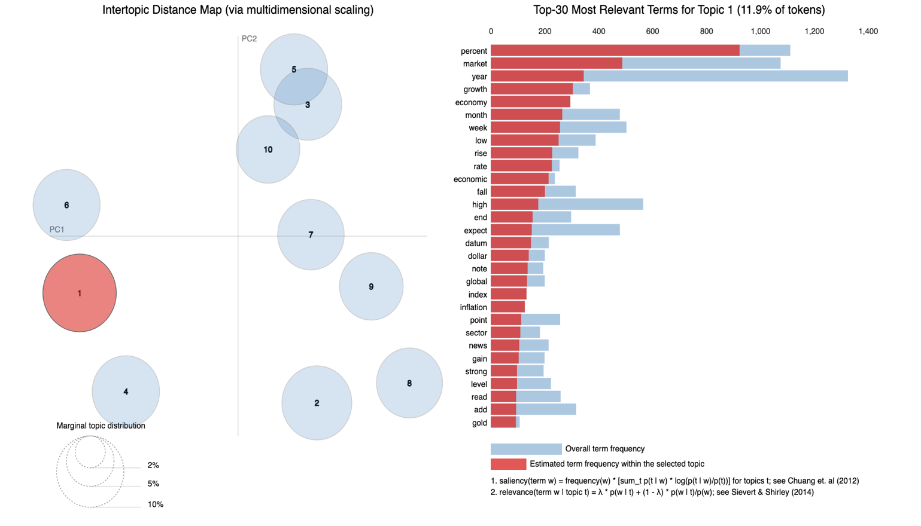

Figure 52: Intertopic Distance Map for CNBC

The same topics along with their corresponding keywords are represented as a dual-axis graph representing each keyword's frequency and weight(importance) as shown in Figure 53. The keywords are arranged in descending order from left to right for each subplot starting from the word with the highest weight. For example, in the below plot, it can be noticed that ‘stock’, ‘market’ etc. are the most important keywords for Topic 0.

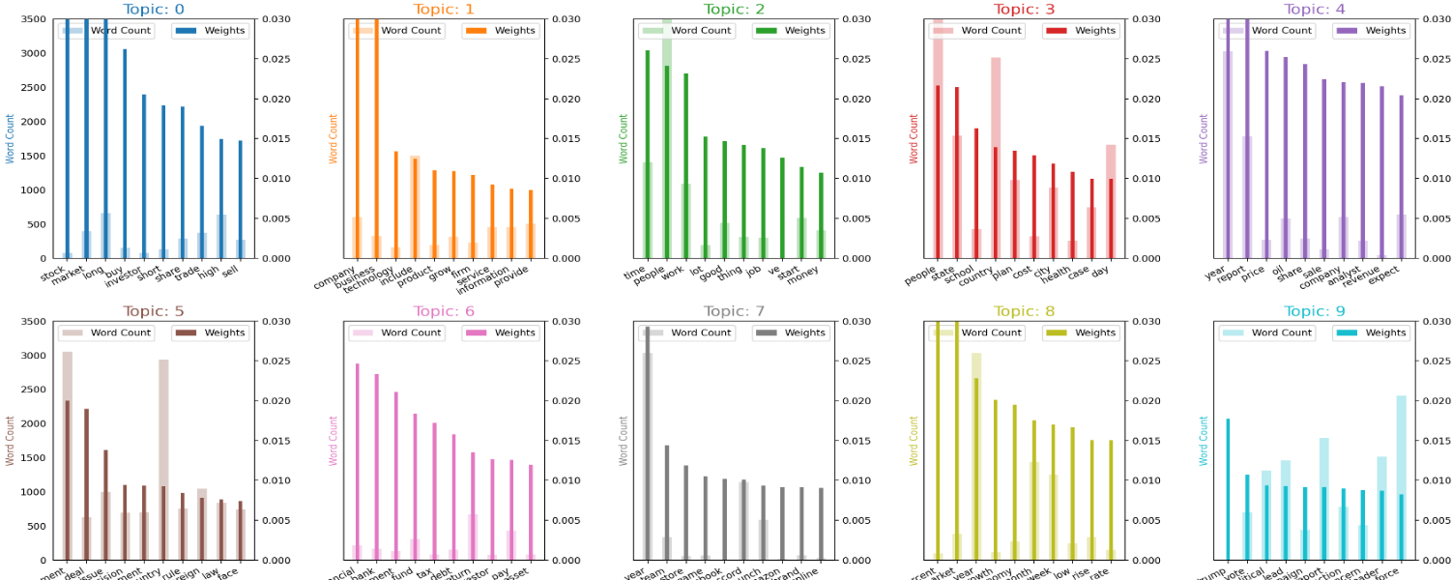

Figure 53: Word Count and importance of Topic Keywords

The topics are now mapped to labels such as ‘Market_Trade’, ‘Market_Business’, ‘Market_Jobs’, ‘Market_Stocks_Shares’, ‘World’, ‘Governmanet’, ‘Market_Investments’, ‘Sports_Entertainment’, ‘Market_Economy’ and ‘Politics’ from a manually created list.Later a word cloud is generated to visualize the keywords for the corresponding topics (now labelled) with the size of the keywords in the cloud ranging from big to small based on their importance as shown in Figure 54.

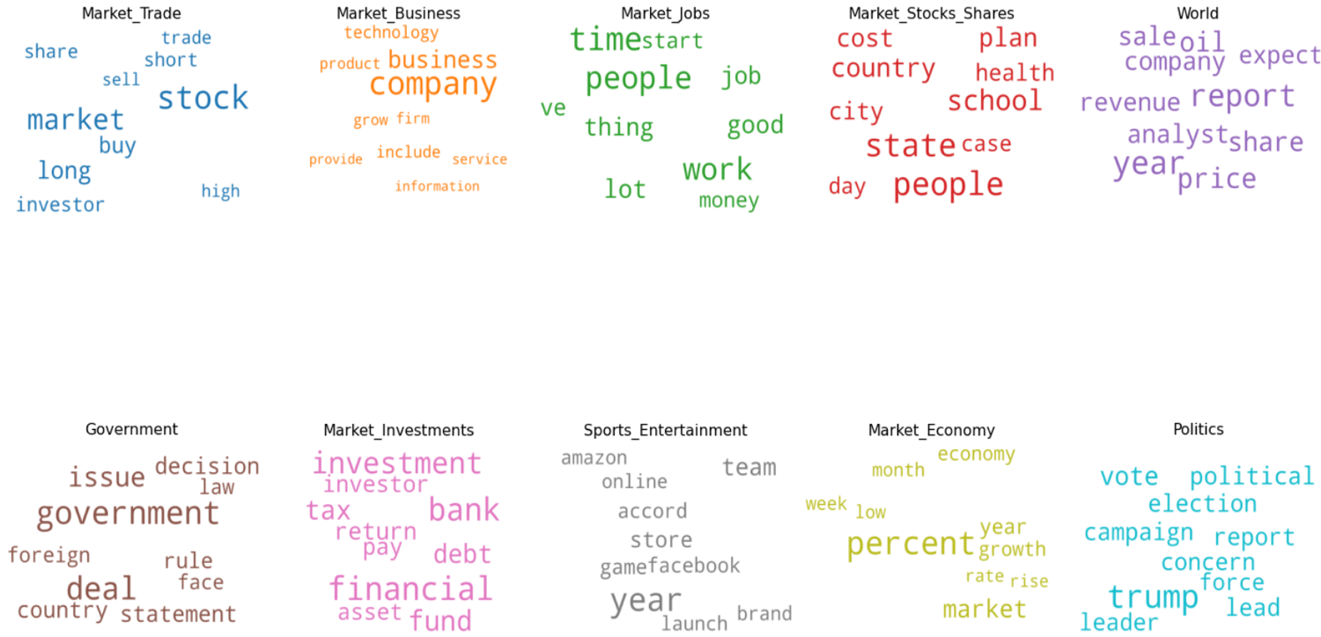

Figure 54: Labeling of Topics based on Keyword

# Findings

In the process of working towards finding a model to accomplish the automatic tagging process and to use them for organizing the data catalog, below are the key findings the team arrived at the end of the project.

## Preprocessor Mechanism

Created a standard mechanism to preprocess and extract candidate keywords from text data using the website URLs in the dataset inventory. The Gensim package had an inbuilt preprocessor function too, but we opted to use our own to be more flexible with adding stop words, choosing the limit of n-grams to be identified and so on.

## System to identify Best Descriptor Tag

Developed a solution system to tag (using the extracted candidate keywords) and classify each dataset into a set of collections based on the theme/genre which then is further compiled to generate metadata tags for the whole collection based on dominant keywords/tags identified in the collection.

The solution system makes use of two implementations of topic modelling using Gensim package in python – Gensim's LDA and Mallet’s LDA (provided as a wrapper in Gensim). Gensim’s LDA model is used to build the initial model and then converted to Mallet for tuning the optimal number of topics. It was found that Mallet performed better for the same number of topics and additionally was useful in identifying the optimal number of topics to feed the model for desired coherence (Table 8).

Table 8: Performance Comparison before and after Tuning Topic Model

|  |  |  |  |  |  |
| --- | --- | --- | --- | --- | --- |
| **Dataset** | **Initial No. Of Topics** | **Coherence score – Gensim LDA** | **Coherence score – Mallet LDA** | **Optimal No. Of Topics** | **New Coherence** |
| **Aljazeera** | **8** | **0.409** | **0.45** | **10** | **0.464** |
| **BBC** | **10** | **-** | **0.449** | **8** | **0.451** |
| **CNN** | **8** | **-** | **0.56** | **10** | **0.592** |
| **Japan Times** | **10** | **-** | **0.339** | **2** | **0.412** |
| **CNBC** | **2** | **-** | **0.423** | **10** | **0.46** |

The table also infers that the optimum number of topics is usually between 8 – 10. This is true along with the fact that 10 was the restriction given to the tuner for a maximum number of topics to be distinguished to prevent the problem of over classification. Subsequently, The Japan Times is the only dataset with 2 topics/collections and very low coherence. This is because it just has 600 rows of data, reflecting a very poor quantity for the model to distinguish between.

## Model Tuner

The normal elbow approach of finding the optimum point before the graph flattens or descends was not opted here since the coherence was going to fluctuate drastically and the first sign of flattening was not the best way to determine the peak as shown in Figure 55, which shows the plot for the model tuning done for CNN dataset. Although the graph flattens at 6, we can find a much better coherence at 10 (a difference of about 6%) and hence the elbow approach would not be suitable here.

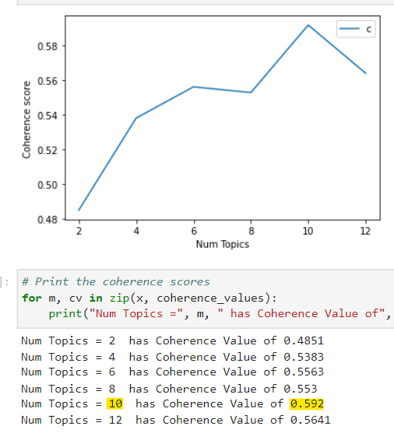

Figure 55: Finding optimal number of topics to classify the CNN dataset

## Baseline Standard for Tagging - DCAT

After classification, the collections were packaged with the tag field names referencing DCAT vocabulary (Figure 56) as well as our own to set a baseline standard enabling interoperability between organizations and improved data discovery.

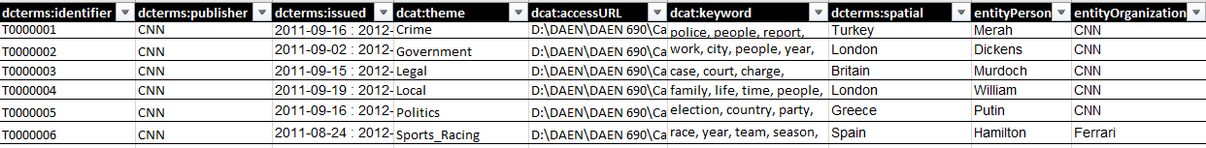

Figure 56: Tagged Package of CNN with DCAT field names

## Use Case Scenario

Assuming an organization that maintains a dataset inventory based on URLs, this solution will enable them to tag data and upload the collections into their catalog as records. The tags will be useful in building a search engine for the catalog that will allow users to pull datasets based on keywords that match the tags. For example, if a user wants to find a data collection related to sports and racing, he can enter the same in the search box and the collections with tags that match this keyword in the data catalog will be retrieved by the search engine as shown in Figure 57.

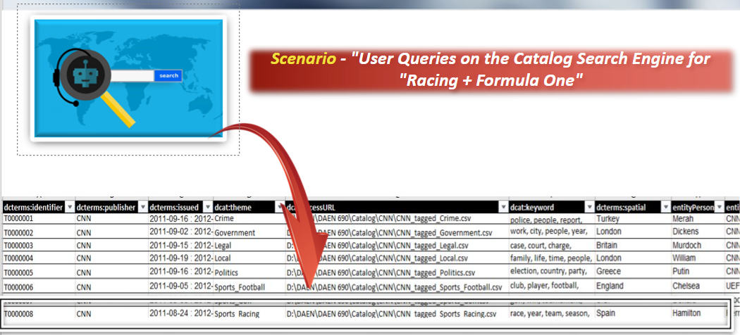

Figure 57: Use Case Scenario for Catalog Search Engine

## Lessons Learned

Understanding the Data Management and Data Catalog concepts was very challenging, as well as how our solution and efforts fit into this big picture. We learned that,

1. More time should have been spent on thoroughly understanding this problem domain.
2. Setting hard boundaries for our scope to purely focus on just metadata tagging was important – as there were times when we wavered into areas of information retrieval systems more than needed.
3. To scale down our solution system to available resources – as the initial data inventory was excessive to handle in a non-cloud infrastructure.
4. Setting version control for codes – as once our solution was beginning to develop in size and functionality, we started to face problems. This was fixed later by running all codes in one fixed environment, with a proper naming convention to avoid overwriting modifications and losing changes.

# Summary

Data Bees team has successfully developed a pipeline to resolve the problem of automating tagging process in order to use them for organizing the data catalog. The pipeline includes three stages which are web scraping, topic mapping, and data catalog organizing. In the web scraping stage, clean text was extracted from the news articles feed to use for topic modeling. Moreover, admin and entity keywords/tags have been also generated for the data catalog organizing such as publisher name and publication date as admin tags besides a person, location and organization as entity tags. In the next stage, topic mapping, an LDA model has been built to determine the dominating topics from the collection of documents. To find the optimal number of topics that can be used to build the model, the coherence was calculated corresponding to the LDA model with a respective number of topics. A threshold of ten topics has been determined to avoid overclassifying the dataset collections. The optimal number of topics for text collections that provided the best coherence score of 0.46 is ten topics. The approach produces ten collections of keywords that appear together as subjects and determines the percentage of contribution of each topic such as politics, crime, family, government etc. In the last stage, the data catalog organizing was done for each collection of text by assigning each to its dominant topic, and then, assigning the top entity keywords along with the published date period. To receive the result of a package of tagged data collections prepared to upload to a data catalog.

# Future Work

Here are a few areas where the project could be improved. This project aims to evaluate what is feasible, what can be implemented, and what cannot, within a given time frame. The following four key phases have been established for both future work and procedure improvements:

1. Topic indexing automatically:

Topic modeling is executed with the use of LDA Mallet to identify topics or keywords from each of the databases. The bar graphs revealed which keyword is repeated most frequently in the text by its count, and for each keyword, weight is allocated to it according to the importance factor and it is assigned to Topic(n) as an index. The tags assigned to each topic are then displayed as a word cloud. These tags were developed manually by mapping the topics' index to a dictionary of tags or labels. This tagging process can be automated by using an AI classifier, which will read the topic keywords, compare them to its knowledge base, and provide a label. By doing this, the task will require less manual intervention in the future.

1. Support other languages:

The topic modeling algorithm currently only supports English. Future versions of the model could provide integration for additional languages like Spanish, Portuguese, etc.

1. Working on accent encoding:

The model is unable to interpret accents, such as those in French, either because it ignores this information or because it is unable to comprehend the concept of accents. Future research can focus on strategies for eventually including accents in the model to support a wide variety of languages.

1. Extending into new areas of expertise:

As news articles cover the bulk of topics across all domains, this makes up the whole dataset for the project. The scope of this area can include health care, education, and other industries.

# Appendix A: Code References

## GitHub

All code and datasets used for this project can be viewed at the Team’s GitHub page (link below).

<https://github.com/GMU-Capstone-690/Data-Tagging-via-Content-and-Standards>.

## Data Location

Navigate through the Team’s GitHub site link – ‘<https://github.com/GMU-Capstone-690/Data-Tagging-via-Content-and-Standards/tree/main/Data%20Collection>’ to find and access our datasets.

## Code Instructions

For detailed step-by-step process on running the codes, navigate to the ‘Model Implementation’ section in the Team’s GitHub site link- <https://github.com/GMU-Capstone-690/Data-Tagging-via-Content-and-Standards#model-implementation>.

## Credits

George Mason Data Analytics Engineering Program: DAEN 690  
Fall 2022 Team Code- Data Bees:

* Shagufta Hassan (<https://www.linkedin.com/in/shagufta-hassan-08/>)
* Durafshan Jawad (<https://www.linkedin.com/in/durafshan-jawad-5b07b0133/>)
* Lama Alznaidi (<https://www.linkedin.com/in/lama-a-a51420152/>)
* Prajna Shetty (<https://www.linkedin.com/in/prajna-shetty-517ab0244/>)
* Madesh Chinnathevar Ramesh (<https://www.linkedin.com/in/madeshcr/>)

# Appendix B: Risk Section

## Sprint 1 Risks

|  |  |  |  |  |
| --- | --- | --- | --- | --- |
| Risk Name | Description | Probability | Impact | Mitigation |
| Resources | The GDELT dataset could be queried using Google’s Big Query. However, it has become a paid service beyond the limit. Raw files can be combined and run locally but could end up extending the given period for the project | Medium | Medium | Resolved in later sprints |
| Excessive Tagging | Adding too many descriptors and tags reduces searchability | Medium | High | Limited the type of tags to a minimum set of specific entities without redundancy |

## Sprint 2 Risks

|  |  |  |  |  |
| --- | --- | --- | --- | --- |
| **Risk Name** | **Description** | **Probability** | **Impact** | **Mitigation** |
| Invalid or Expired URL | Some of the links provided in URL column could be expired and might not be useful in extracting content for tagging. | low | medium | Remove expired links, or correct the invalid links in case of format issues |
| Inadequate Resource | The total size of the datasets is close to 13GB. Running them locally could be a challenge considering data conditioning operations are also to be done on them | High | High | Break down the tasks in segments,  use arguments like ‘chunk_size’ when reading the csv files into dataframes to spare system’s RAM, could use Databricks free community edition for running processes on cloud. |

## Sprint 3 Risks

|  |  |  |  |  |
| --- | --- | --- | --- | --- |
| **Risk Name** | **Description** | **Probability** | **Impact** | **Mitigation** |
| Processing time and memory | NLP tasks take a lot of processing time and memory. Considering 29K plus rows of text data, running them locally using normal JupyterLab environment is not a feasible option. | High | High | Databricks is not viable as the free edition allows only 2GB of data to be uploaded while ours is 12 GB. Currently exploring Spark environment and Google Colab for alternatives. |
| Articles requiring Subscriptions | Some articles require subscriptions to view completely and data is being missed out during extraction. This causes the descriptor tags extracted to describe the article with less accuracy. | Low | Low | We might choose to drop the articles that require subscription in total if text content extracted is very minimal. |

## Sprint 4 Risks

|  |  |  |  |  |
| --- | --- | --- | --- | --- |
| **Risk Name** | **Description** | **Probability** | **Impact** | **Mitigation** |
| Limited Resources | Generating visualization for such a huge dataset is very demanding. Previous attempts to use spark, collab and databricks have all been less fruitful without opting to pay for services. | High | Medium | Decision to treat datasets individually and not combine has allowed to us to operate in local machine so far. |

## Sprint 5 Risks

# Appendix C: Agile Development

## Scrum Methodology

Sprint 1

Title: Problem Definition

Dates: 08/22/22 – 09/11/2022

Sprint 2

Title: Dataset

Dates: 09/12/22 – 10/03/2022

Sprint 3

Title: Algorithms & Analytics

Dates: 10/03/22 – 10/23/2022

Sprint 4

Title: Visualization & ML Model

Dates: 10/24/22 – 11/13/2022

Sprint 5

Title: Final Presentation

Dates: 11/14/22 – 12/05/2022

Scrummethodology was adopted for management and involved 5 sprints in total, each of them extending for about 3 weeks. As for tracking, YouTrack software by JetBrains was utilized to record and follow up on any issues as well as user stories that came up during our project.

In the first week of our project, we assigned roles to each of the team members after identifying respective strengths and weaknesses and the roles defined were as below:

1. Product Owner – Lama Alznaidi
2. Developers

* Durafshan Jawad
* Shagufta Hassan
* Prajna Shetty Jagannath

1. SCRUM Master – Madesh Chinnathevar Ramesh

## Sprint 1 Analysis

During the first sprint, the Data Bees team worked on understanding the project topic, defining the problem, and exploring the possible datasets. Even though some of Data Bees’ members have previous experience in Machine Learning (ML) and Natural Language Processing (NLP), Tagging Data was a new topic for everyone in the team. Thus, thinking of a problem to be resolved by tagging data and choosing a focus among the three proposed focuses was a bit of a challenging task. After several meetings and discussions with Data Bees member, Dr. Howard, and the partner (MITRE), Data Bees were able to fully understand the project focus to tag and the expected outcomes. A great deal of research and readings have been done by Data Bees members to finally finalize the problem statement and the starting datasets.

## Sprint 2 Analysis

In this sprint, Data Bees finalized the project dataset to be one expert dataset by combining six different datasets from six diverse news sources. Not only that, but a complete Data Acquisition process has also been done on data by the team including data importing, exploring, cleaning, and combining. The big challenge in this sprint was finding the suitable dataset for our problem objective in terms of sufficiency and validity. Another challenge faced by the team was the memory needed to run code on a 13 GB dataset. At the end of this sprint, the team members, with the help of Dr. Howard, were able to conclude a dataset of more than 29k news articles' URLs.

## Sprint 3 Analysis

This sprint was all about analyzing the datasets and finding the suitable algorithm that serves the project purposes. The first step was extracting clean text, title, and published date. The next step was extracting keywords/tags – Person, Location, Organization. The final one was Identifying and tagging topics from extracted clean text using LDA. We had some computing resource limitations that consumed a lot of time and effort, but we successfully were able to run our analysis on get a sense of what we have.

## Sprint 4 Analysis

This sprint involved generating visualizations for exploration and analysis steps that will be helpful for delivering the intent of the project better. This includes word clouds (generated from titles of the articles), charts and graphs showing differences before and after text preprocessing, visualizations to show topic labelling, topic distributions and keyword importance. With limited scope for generating visualization with ‘tagging’ as our focus, we struggled in the beginning but were successful in bringing out some useful graphics in the NLP part of our project.

## Sprint 5 Analysis

In this sprint, we packaged the tagged collections, summarized our results and highlighted key findings along with pending works related to documentation and refining code structures. The tag packages were mimicked on how they would look if entered as a record in a data catalog. This helped in showing a use case scenario on how our solution would fit in the bigger picture of data cataloging. We identified gaps and places to improve in the solution and noted them for future work.

# Appendix D: Additional Visualizations and Graphics

## Text Preprocessing for Aljazeera (Unigrams, Bigrams and Trigrams)

* Visualizing Unigrams in text before and after removing stop words

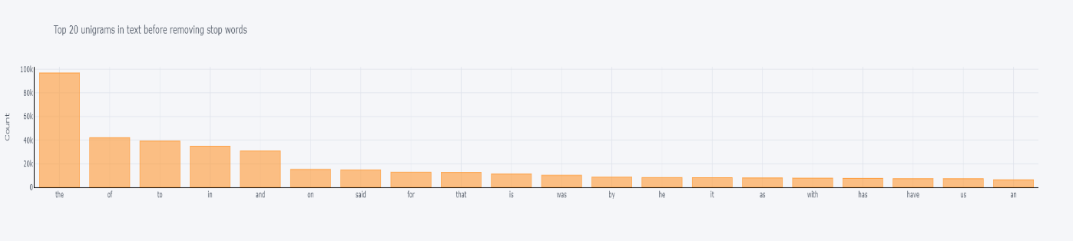

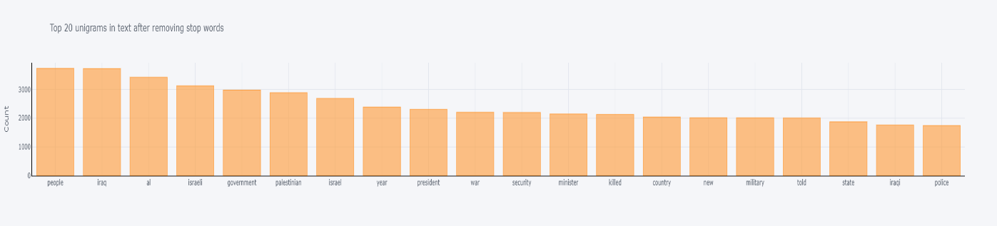

* Visualizing Bigrams in text before and after removing stop words

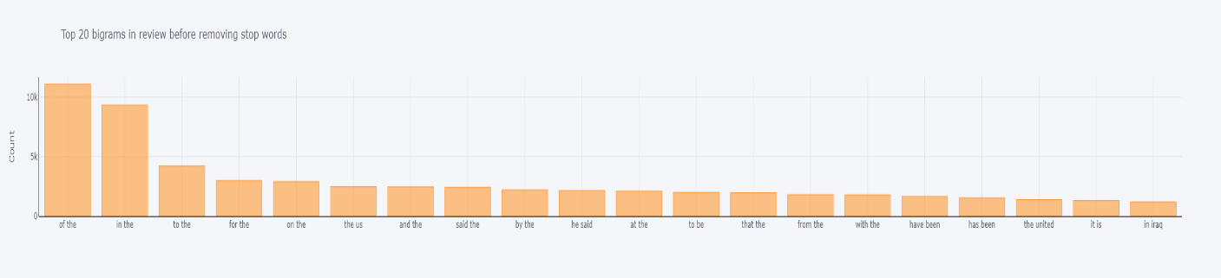

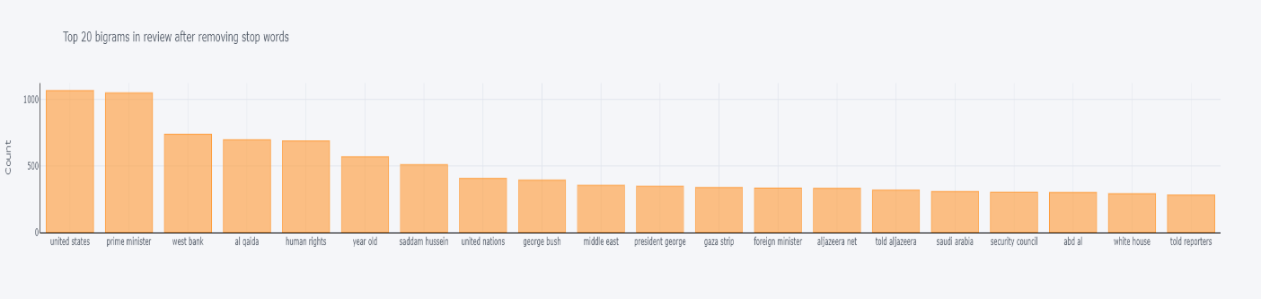

* Visualizing Trigrams in text before and after removing stop words

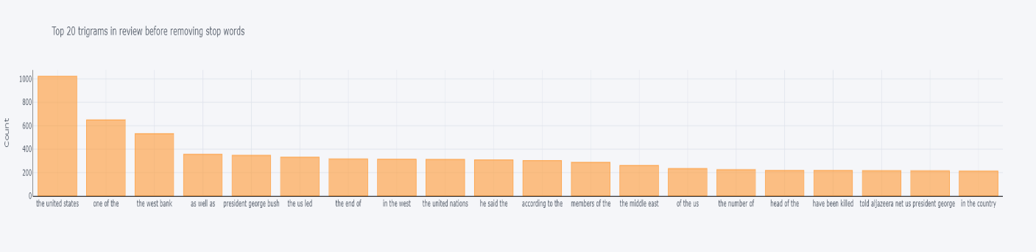

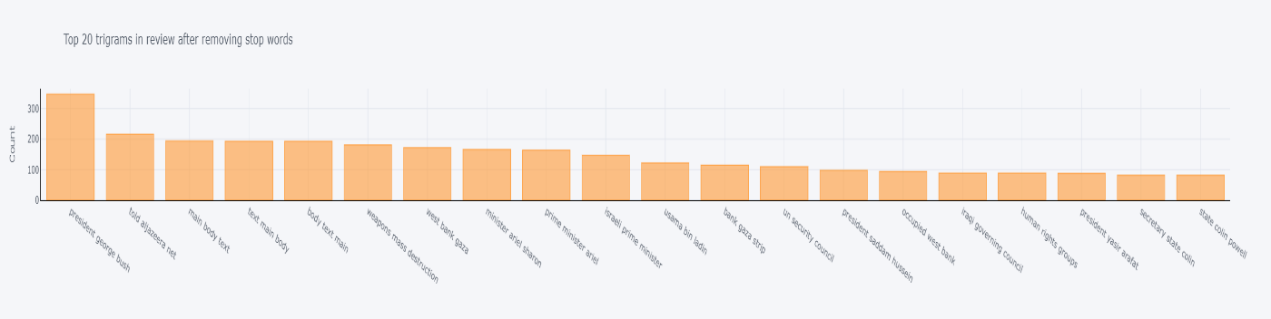

## Text Preprocessing for Aljazeera (Unigrams, Bigrams and Trigrams)

Visualizing Unigrams in text before and after removing stop words

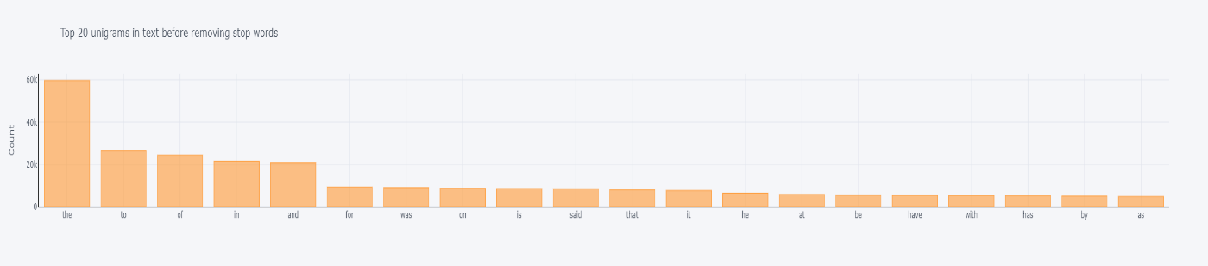

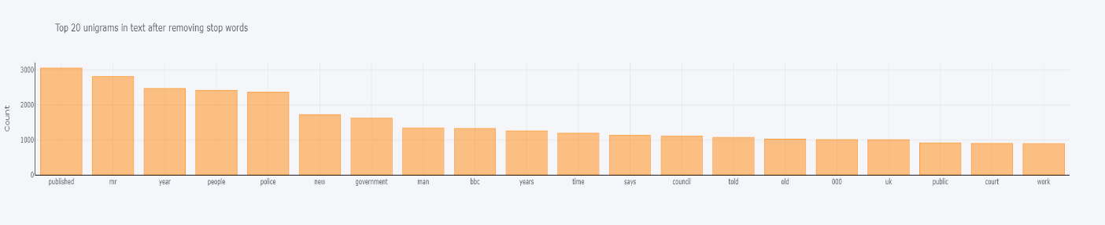

Visualizing Bigrams in text before and after removing stop words

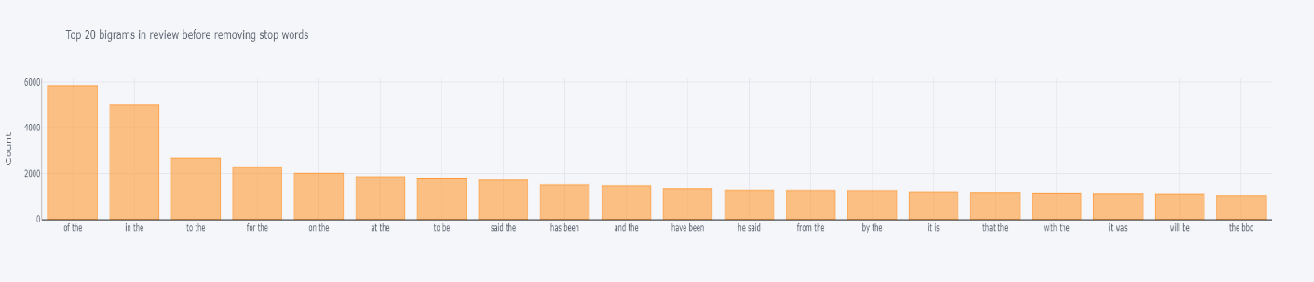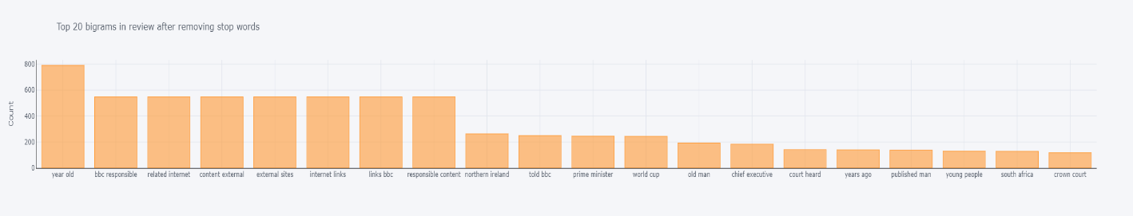

Visualizing Trigrams in text before and after removing stop words

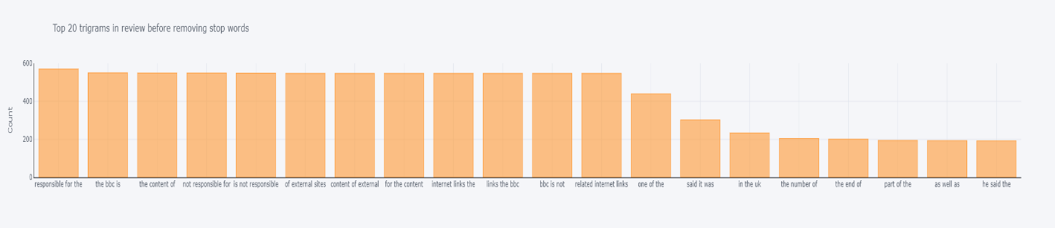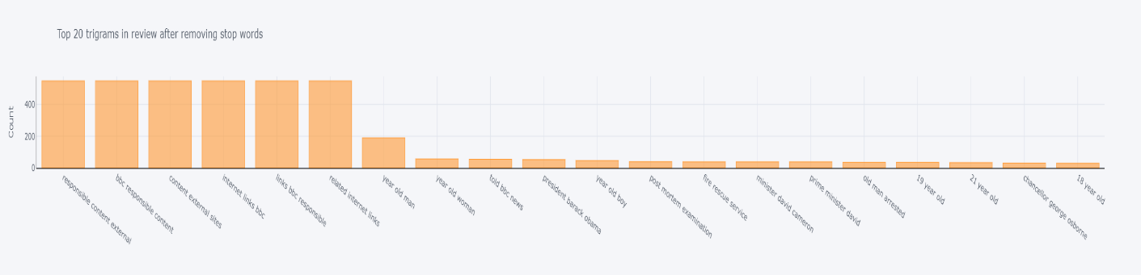

## Text Preprocessing for Japan Times (Unigrams, Bigrams and Trigrams)

* Visualizing Unigrams in text before and after removing stop words

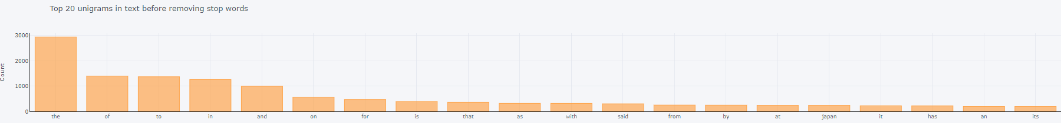

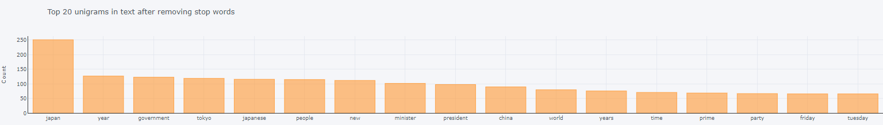

* Visualizing Bigrams in text before and after removing stop words

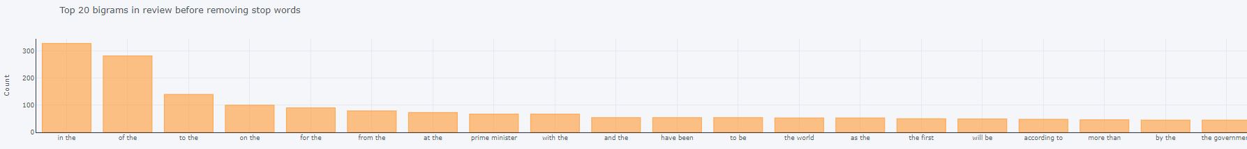

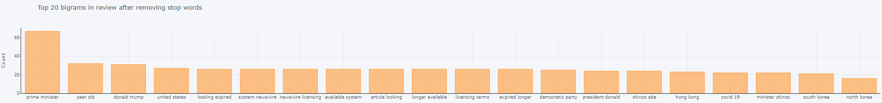

* Visualizing Trigrams in text before and after removing stop words

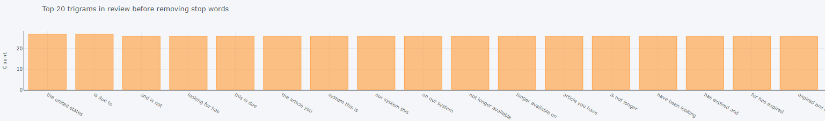

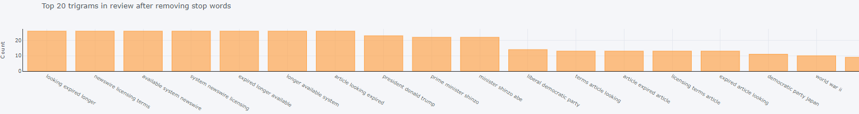

# References

**[1]** [Jacquelyn Bulao](https://techjury.net/author/jackieb/), Sep 05, 2022, How Much Data Is Created Every Day in 2021?,

<https://techjury.net/blog/how-much-data-is-created-every-day/#gref>

**[2]** GeeksofGeeks,What is Semi-structured data?, <https://www.geeksforgeeks.org/what-is-semi-structured-data/>

**[3]** [Vangie Beal](https://www.webopedia.com/author/vangie-beal/), May 19, 2011, Updated on: June 11, 2021, Unstructured Data,

<https://www.webopedia.com/definitions/unstructured-data/>

**[4]** CQL, The council on Quality and Leadership, 12 reasons why data is important, <https://www.c-q-l.org/resources/guides/12-reasons-why-data-is-important/>

**[5]** Nested Knowledge, Best Practices for Tagging,

<https://wiki.nested-knowledge.com/doku.php?id=wiki:guide:research:tag>

**[6]** [TechTarget Contributor](https://www.techtarget.com/contributor/TechTarget-Contributor), key-value pair (KVP), <https://www.techtarget.com/searchenterprisedesktop/definition/key-value-pair>

**[7]** [Vijay Kanade](https://www.spiceworks.com/user/about/vijaya-kanade)April 27, 2022, What Is a Data Catalog? Definition, Examples, and Best Practices,

<https://www.spiceworks.com/tech/big-data/articles/what-is-a-data-catalog-definition-examples-and-best-practices/>

**[8]** [Craig Stedman](https://www.techtarget.com/contributor/Craig-Stedman), August 2022, Data Catalog, <https://www.techtarget.com/searchdatamanagement/definition/data-catalog>

**[9]** OCI (Oracle Cloud Infrastructure), What Is a Data Catalog and Why Do You Need One?, <https://www.oracle.com/big-data/data-catalog/what-is-a-data-catalog/>

**[10]** [Precisely Editor](https://www.precisely.com/blog/author/media-shower), November 8, 2021, Why You Need a Data Catalog,

<https://www.precisely.com/blog/datagovernance/why-you-need-a-data-catalog>

**[11]** Tags and tag template,

<https://cloud.google.com/data-catalog/docs/tags-and-tag-templates>

**[12] A** Quick Guide to Data Catalog, <https://www.cms.gov/files/document/data-catalog-quick-reference-guide.pdf>

**[13]** [Aberdeen Strategy & Research](https://www.aberdeen.com/), <https://www.aberdeen.com>

**[14]** Amal Job, June 29, 2021, “Text Mining: How to Extract Valuable Insights from Text Data”,

<https://www.g2.com/articles/text-mining#why-is-text-mining-important>.

**[15]** Fabio Chiusano, November 29, 2021, “How to train a Topic Tagging model to assign high-quality topics to articles”,

<https://towardsai.net/p/l/how-to-train-a-topic-tagging-model-to-assign-high-quality-topics-to-articles>.

[16] Greg Rafferty, December 6, 2018 "Topic Modeling with Latent Dirichlet Allocation",

<https://towardsdatascience.com/basic-nlp-on-the-texts-of-harry-potter-topic-modeling-with-latent-dirichlet-allocation-f3c00f77b0f5>

[17] Selva Prabhakaran, March 26, 2018, “Topic Modelling with Genism (Python)”, <https://www.machinelearningplus.com/nlp/topic-modeling-gensim-python/>